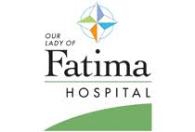
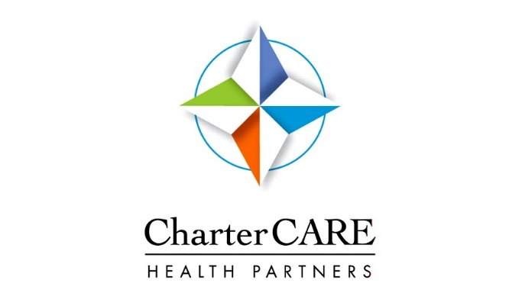

Roger Williams Medical Center
Our Lady of Fatima Hospital
2019 Community Health Needs Assessment
Final Report

Table of Contents

Our Commitment to Community Health | 2
Executive Summary | 3
CHNA Leadership | 3
Service Area Description | 3
CHNA Methodology | 3
Community Engagement | 4
Summary Findings | 4
Community Health Priorities | 6
Board Approval | 6
Full Report of CHNA Findings | 7
The CharterCARE Service Area | 8
Demographic Analysis | 9
County Comparisons | 9
Service Area Zip Code Analysis | 18
Statistical Analysis of Health Indicators | 20
Access to Healthcare | 21
Overall Health Status | 26
Health Behaviors | 28
Mortality | 32
Chronic Diseases | 33
Senior Health | 42
Behavioral Health | 45
Maternal and Child Health | 55
Reportable Diseases | 60
Key Informant Survey Results | 63
Community Partner Forum Summary | 75
Evaluation of Impact from 2016-19 CHNA Implementation Plan | 78
Prioritization Process and Identified Priority Areas | 80
Appendix A: Secondary Data References | 81
Appendix B: Key Informant Survey Participants | 83
Appendix C: Community Partner Forum Participants | 84

Our Commitment to Community Health

CharterCARE Health Partners is a regional coordinated care health provider network that includes two acute care hospitals, Our Lady of Fatima Hospital and Roger Williams Medical Center. Our coordinated care model allows us to deliver services to patients at multiple levels of care, at the right time and place and at lower costs. This way of organizing and delivering health care services enables us to optimize population health management strategies in Rhode Island.

Our Lady of Fatima Hospital is a general acute care facility offering treatment in numerous medical surgical specialties with regionally recognized programs in acute rehabilitation, behavioral health and spine surgery. The hospital is dedicated to the highest level of advanced medical care with a personal touch. Many of our programs—like our surgical program for hip and knee replacement and our diabetes programs—have received first-in-the-region certifications from trusted names like The Joint Commission.

Roger Williams Medical Center is known as a health provider focused on the highest level of care in areas such as cancer, digestive diseases and weight loss surgery. We are an academic medical center, affiliated with Boston University School of Medicine, which allows us to train the physicians of tomorrow. The benefits of academic medicine are many: more well-trained physicians and specialists collaborating on your care, access to the latest clinical trials, and treatments that are sometimes not available in a community hospital setting.

CharterCARE also operates a large outpatient surgery center, Blackstone Valley Surgicare, a home health program, CharterCARE Home Health Service,s and an outpatient primary care health center. In addition, CharterCARE operates a large employed physician group, CharterCARE Medical Associates and a large IPA, CharterCARE Provider Group of Rhode Island.

Mission
The mission of CharterCARE Health Partners is to ensure that residents of Rhode Island receive exceptional quality care at the right time, in the right setting, with the utmost compassion and efficiency.

CharterCARE’s Vision
Our vision is to become the health provider of choice for residents of Rhode Island and the partner of choice for physicians and other health care providers, because we offer the best and most personalized patient experience at the best value.
Executive Summary of CHNA Findings
A Statewide Approach to Community Health Improvement

CHNA Leadership
The 2019 Hospital Association of Rhode Island (HARI) was conducted in collaboration with eight Rhode Island hospitals, including Roger Williams Medical Center and Our Lady of Fatima Hospital. collectively as CharterCARE.

A steering committee of hospital and HARI representatives coordinated and oversaw the CHNA research and stakeholder engagement. Throughout the process, CHNA findings were shared with community partners for review and input to determine local health needs, areas of disparity, and opportunities for collaboration. Community health consultants assisted in all phases of the CHNA including project management, data collection and analysis, and report writing.

2019 HARI CHNA Steering Committee Members
Gina Rocha, Hospital Association of Rhode Island, Vice President, Clinical Affairs
Otis Brown, CharterCARE, Vice President, Marketing & External Affairs
Laurel Holmes, Westerly Hospital, Director of Community Partnerships & Population Health
Carolyn Kyle, Landmark Medical Center, Director of Public Relations, Marketing & Physician Relations
Kimberly O’Connell, South County Hospital, Vice President and Chief Strategy Officer
Gail Robbins, Care New England, Senior Vice President of Planning & Finance

Consulting Team
Colleen Milligan, MBA, Director, Healthcare Practice, Baker Tilly
Catherine Birdsey, MPH, CHNA Research Manager, Baker Tilly
Jessica Losito, BA, Research Consultant, Baker Tilly

CHNA Methodology
The 2019 CHNA was conducted from April 2018 to June 2019 and included quantitative and qualitative research methods to determine health trends and disparities within the CharterCARE service area compared to health indicators across Rhode Island and the nation. Primary study methods were used to solicit input from healthcare consumers and key community stakeholders representing the broad interests of the community. Secondary study methods were used to identify and analyze statistical demographic and health trends.

Specific CHNA study methods included:
- An analysis of existing secondary data sources, including public health statistics, demographic and social measures, and health care utilization
- A key informant survey with health and human service providers
- Focus groups and community discussions with local stakeholders to review CHNA findings and collect feedback

The CHNA was conducted in a timeline to comply with IRS Tax Code 501(r) that requires not-for-profit hospitals to conduct a CHNA every three years as set forth by the Affordable Care Act (ACA). The CHNA findings will be used to guide each hospital’s community benefit initiatives and engage local partners in collectively addressing identified health needs.
Community Engagement
Community engagement was an integral part of the CHNA research. In assessing the health needs of the community, input was solicited and received from persons who represent the broad interests of the community, as well as underserved, low income and minority populations. These individuals provided wide perspectives on health trends, expertise about existing community resources available to meet those needs, and insights into service delivery gaps that contribute to health disparities. Research and planning was conducted in coordination with the Rhode Island Department of Health and the local Health Equity Zones (HEZ) to promote collaboration across existing initiatives and reduce duplication of activities.

Summary Findings
Roger Williams Medical Center and Our Lady of Fatima Hospital, collectively as CharterCARE Heath Partners, serve some of the most high need communities in Rhode Island. Rhode Island’s core cities, (designated as cities in which 25% or more children live in poverty) Central Falls, Pawtucket, Providence, and Woonsocket, are located within the hospital’s combined service area. Residents residing in these communities and others across the service area experience greater socioeconomic disparities and increased health needs than in other parts of the state.
CharterCARE serves all of Rhode Island’s four core cities, which experience heightened economic distress and greater potential for health inequity

Cyclical poverty, exposure to violence, and higher disease incidence, lead to shortened life expectancy for many residents. Reducing health disparities and increasing equitable access to services across the service area requires strategic community investment by CharterCARE.

Community health needs across the CharterCARE service area continue to be centered on treatment and prevention of mental health and substance use disorders; access to care to reduce health disparities related to chronic disease mortality; and improving the well-being of mothers, infants, and children.

Mental Health and Substance Use Disorders
Key informant survey participants indicated that behavioral health needs were the most pressing community health needs that affect residents. Statistical data reinforced this perception on numerous measures. Rates of depression, suicides, and other deaths due to mental and behavioral health disorders are higher than national comparisons. Within the state, opioid use and overdose deaths are highest in Woonsocket, Providence, Central Falls, Pawtucket, and West Warwick, among other communities within the CharterCARE hospitals’ service area.

Health Disparities Related to Chronic Disease Mortality
Despite decreasing uninsured rates and more residents reporting a regular medical home, chronic disease deaths due to heart disease, diabetes, and lung cancer are higher than national benchmarks. Socioeconomic disparities increase health disparities for residents in underserved communities like the core cities. Fewer health providers are available within these communities, and fewer still that reflect patients’ languages and cultures. Service area seniors have more comorbidities and are more likely to live alone compared to the national averages. Risk factors, including high blood pressure, high cholesterol, lack of physical activity, and behavioral health comorbidities are key drivers for increased deaths. Lung cancer incidence is correlated with higher rates of smoking and higher levels of radon in homes across the service area.

Maternal and Child Health
Poor women and children are at increased risk for maternal and childhood disparities. Children residng in the core cities experience more violence, abuse and neglect than in other communities, resulting in higher rates of adverse childhood experiences (ACEs). In turn, ACEs can lead to increased risky behaviors, higher rates of mental and substance use disorders, lower education attainment, and a continued cycle of poverty for families. While nearly 50% less than a decade ago, nearly 2,400 of the 3,000 statewide teen births were to mothers residing within the core cities.

Community Health Priorities
To work toward health equity, it is imperative to prioritize resources and activities toward the most pressing health and crosscutting needs within communities. In determining the issues on which to focus efforts over the next three-year cycle, CharterCARE and its CHNA hospital partners solicited input from community partners and stakeholders to align efforts with existing initiatives headed by the Rhode Island Department of Health, the HEZs, and other community partnerships. Qualitative feedback was considered in conjunction with statistical health and socioeconomic data to identify trends and the impact of social determinants of health. The CHNA Steering Committee adopted statewide community health priorities to be addressed independently and collaboratively by each hospital.

In line with CHNA Steering Committee recommendations, CharterCARE adopted the following health priorities on which to focus for the 2019–2022 reporting cycle. Specific resources and services to address these priority needs are outlined in CharterCARE’s Implementation Plan.

CharterCARE Community Health Priorities for 2019-2022 Implementation Plan
Behavioral Health: advance the treatment of mental health and substance use disorders
Chronic Disease: expand access to care to reduce health disparities for chronic disease
Maternal and Child Health: improve the well-being of mothers, infants, and children

Board Approval
The CharterCARE board of directors - and its Community Advisory Boards - reviewed and approved the 2019 CHNA Final Report and corresponding Implementation Plans in March, 2020. The report is available for review and comment on the CharterCARE website.

Full Report
of CHNA Findings

CharterCARE Service Area

Population Overview
CharterCARE operates two acute care hospitals, Our Lady of Fatima Hospital and Roger Williams Medical Center. The combined primary service area for the two hospitals comprises 25 Rhode Island zip codes, primarily located in Kent and Providence counties. The 2018 population of the service area is 633,682 and is projected to increase 1.2% by 2023.

CharterCARE Primary Service Area
Our Lady of Fatima Hospital
Roger Williams Medical Center
Primary Service Area
Zip Codes
02809, Bristol
02814, Chepachet
02816, Coventry
02828, Greenville
02859, Pascoag
02860, Pawtucket
02864, Cumberland
02885, Warren
02886, Warwick
02888, Warwick
02889, Warwick
02893, West Warwick
02895, Woonsocket
02903, Providence
02904, Providence
02905, Providence
02907, Providence
02908, Providence
02909, Providence
02910, Cranston
02911, North Providence
02914, East Providence
02917, Smithfield
02919, Johnston
02920, Cranston
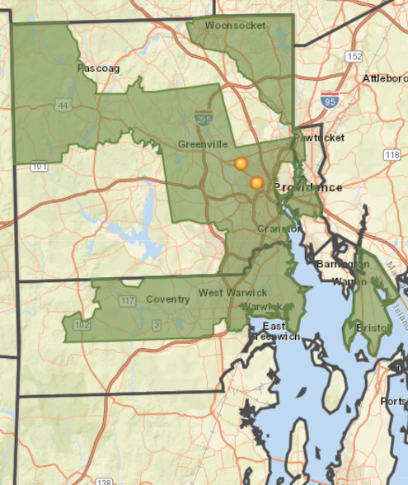

CharterCARE Primary Service Area Population Growth
2018 Population | % Growth 2010-2018 | % Growth 2018-2023
633,682 | 1.2% | 1.2%

CharterCARE Service Area
Demographic Data Analysis

Analyses of demographic and socioeconomic data is essential in understanding health trends and determining key drivers of health status. Socioeconomic indicators play a significant role in community and individual health. Known as social determinants of health, they are defined as factors within the environment in which people live, work, and play that can affect health and quality of life. Social determinants of health are often the root causes of health disparities. Healthy People 2020 defines a health disparity as “a particular type of health difference that is closely linked with social, economic, or environmental disadvantage.”
Social determinants of health are factors within the environment in which people live, work, and play that can affect health and quality of life

County data are presented with comparisons to Rhode Island and national data sets to demonstrate broad trends and areas of strength and opportunity. Demographic analysis by zip code follow the county level analysis to provide a detailed view of population statistics. All reported data were provided by ESRI Business Analyst, 2018 and the US Census Bureau unless otherwise noted.

Population Trends
Both Roger Williams Medical Center and Our Lady of Fatima are located in Providence County, the most populous county in the state. The population of Providence County increased 1.8% between 2010 and 2018, and is projected to continue growing at a similar rate through 2023.

Population Growth
 | 2018 Population | % Growth 2010–2018 | % Growth 2018–2023
Bristol County | 49,418 | -0.9% | -0.2%
Kent County | 167,033 | 0.5% | 0.6%
Newport County | 84,539 | 2.0% | 0.9%
Providence County | 637,835 | 1.8% | 1.5%
Washington County | 128,703 | 1.4% | -0.2%
Rhode Island | 1,067,528 | 1.4% | 1.1%
Source: ESRI, 2018

Across the state, and consistent with the nation, the population that identifies as White is projected to decrease through 2023, while the percentage of residents identifying as Asian, Black/African American, and/or Latinx is projected to increase. In Rhode Island this trend is due in large part to the older age of the White population compared to those of other races and ethnicities. Fewer White women in Rhode Island are in their childbearing years compared to minority women.

2018 Population Overview
 | Asian | Black/ African American | White | Latinx  (any race) | Primary Language Other than English*
Bristol County | 2.2% | 1.2% | 93.7% | 3.2% | 12.1%
Kent County | 2.6% | 1.9% | 91.1% | 5.1% | 8.7%
Newport County | 1.9% | 4.3% | 88.0% | 6.3% | 10.3%
Providence County | 4.4% | 9.5% | 68.7% | 23.4% | 30.5%
Washington County | 2.0% | 1.4% | 92.6% | 3.4% | 6.4%
Rhode Island | 3.6% | 6.5% | 77.8% | 15.9% | 21.6%
United States | 5.7% | 12.9% | 70.0% | 18.3% | 21.2%
Source: ESRI, 2018
*Data are reported for 2012–2016 based on most recent records available.

Population by Race/Ethnicity as a Percentage of Total Population (Projected Change)
 | Asian |  | Black/African American |  | White |  | Latinx
 | 2010 | 2023 | 2010 | 2023 | 2010 | 2023 | 2010 | 2023
Bristol County | 1.4% | 2.9% | 0.8% | 1.5% | 95.7% | 92.1% | 2.0% | 4.3%
Kent County | 2.0% | 3.1% | 1.5% | 2.3% | 93.4% | 89.3% | 3.2% | 6.7%
Newport County | 1.6% | 2.1% | 3.5% | 4.7% | 90.2% | 86.4% | 4.2% | 8.1%
Providence County | 3.7% | 5.0% | 8.5% | 10.3% | 73.4% | 65.4% | 18.8% | 27.0%
Washington County | 1.6% | 2.2% | 1.2% | 1.5% | 93.8% | 91.7% | 2.4% | 4.3%
Rhode Island | 2.9% | 4.0% | 5.7% | 7.2% | 81.4% | 75.2% | 12.4% | 18.6%
Source: ESRI, 2018

2018 Population by Age
 | 14 years and under | 15–24 years | 25–34 years | 35–54 years | 55–64 years | 65+ years | Median Age
Bristol County | 14.6% | 14.6% | 10.5% | 24.3% | 15.8% | 20.3% | 45.1
Kent County | 15.0% | 10.5% | 12.4% | 26.9% | 15.7% | 19.6% | 44.9
Newport County | 14.4% | 12.9% | 11.3% | 24.8% | 15.5% | 21.2% | 45.3
Providence County | 16.7% | 15.2% | 14.2% | 24.9% | 12.9% | 16.1% | 38.1
Washington County | 14.0% | 16.4% | 10.0% | 23.8% | 16.3% | 19.5% | 44.4
Rhode Island | 15.8% | 14.4% | 13.0% | 25.1% | 14.1% | 17.6% | 40.7
United States | 18.6% | 13.3% | 13.9% | 25.3% | 13.0% | 16.0% | 38.3
Source: ESRI, 2018
2018 Population by Age
 | 65+ years | 75+ years | 85+ years
Bristol County | 20.3% | 9.4% | 3.5%
Kent County | 19.6% | 8.6% | 3.1%
Newport County | 21.2% | 9.2% | 3.1%
Providence County | 16.1% | 7.2% | 2.7%
Washington County | 19.5% | 7.9% | 2.6%
Rhode Island | 17.7% | 7.8% | 2.8%
United States | 16.0% | 6.6% | 2.0%
Source: ESRI, 2018

Economic Measures
The median household income for Rhode Island slightly exceeds that of the nation and there are fewer individuals and children living in poverty than in the nation in general. However, a greater proportion of Rhode Island households receive Food Stamp/SNAP benefits compared to the nation. A higher percentage of families accessing Food Stamp/SNAP benefits is a potentially positive finding because it means that supportive services are accessible, but it also points at greater food insecurity across the state.

The median household income for all counties except Providence exceeds the state and national comparisons. Providence County residents are more likely to live in poverty and receive SNAP benefits. Fewer individuals and children in Kent County live in poverty compared to the state and the nation. The Kent County median household income is the second lowest in the state, but the county has among the lowest rates of poverty for both individuals and children.

Median Household Income and Poverty Indicators
 | Median Household Income | People in Poverty | Children in Poverty | Households with SNAP Benefits
Bristol County | $77,309 | 7.0% | 6.7% | 8.2%
Kent County | $64,878 | 7.8% | 8.9% | 12.0%
Newport County | $76,030 | 9.0% | 11.5% | 9.8%
Providence County | $51,926 | 16.7% | 24.4% | 20.5%
Washington County | $78,882 | 9.6% | 10.1% | 8.6%
Rhode Island | $58,972 | 13.4% | 18.9% | 16.1%
United States | $58,100 | 14.6% | 20.3% | 13.0%
Source: ESRI, 2018; US Census Bureau, 2013–2017
Poverty Rates by Race and Ethnicity
 | White |  | Black/African American |  | Latinx
 | Count | Percentage | Count | Percentage | Count | Percentage
Bristol County | 2,808 | 6.4% | 301 | 47.6% | 127 | 11.2%
Kent County | 12,342 | 8.2% | 191 | 8.2% | 778 | 11.7%
Newport County | 5,680 | 8.0% | 563 | 23.0% | 872 | 20.8%
Providence County | 61,249 | 13.8% | 14,887 | 25.4% | 42,541 | 32.8%
Washington County | 10,166 | 9.0% | 532 | 33.9% | 546 | 17.3%
Rhode Island | 92,245 | 11.2% | 16,474 | 25.1% | 44,864 | 31.0%
Source: US Census Bureau, 2012–2016

The following maps further illustrate poverty rates among Black/African American and Latinx residents, pinpointing areas of disparity by census tract. Among Black/African American residents, the greatest disparity is seen in Providence County, including the core cities, and Washington County. Portions of Bristol County also show greater disparity among Blacks/African Americans.
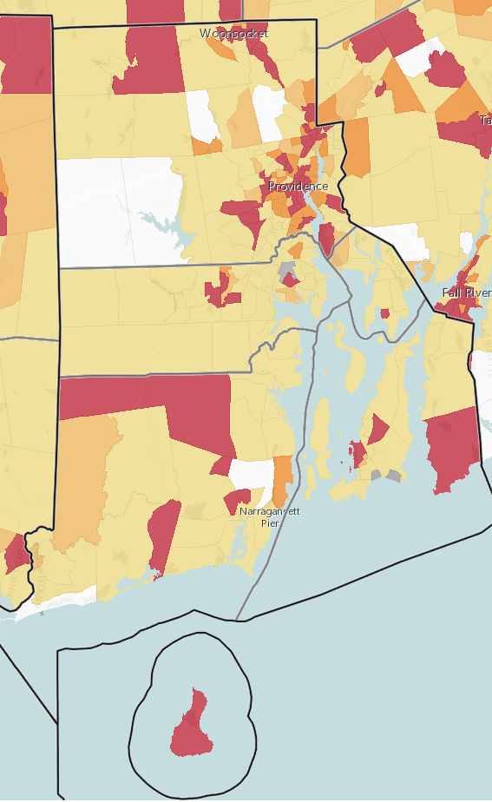  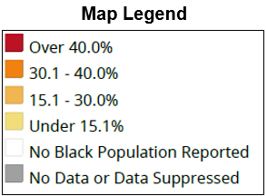  Black/African American Population Below the Poverty Level by Census Tract |  | 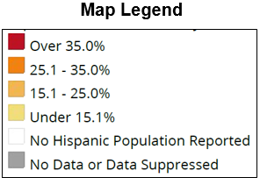  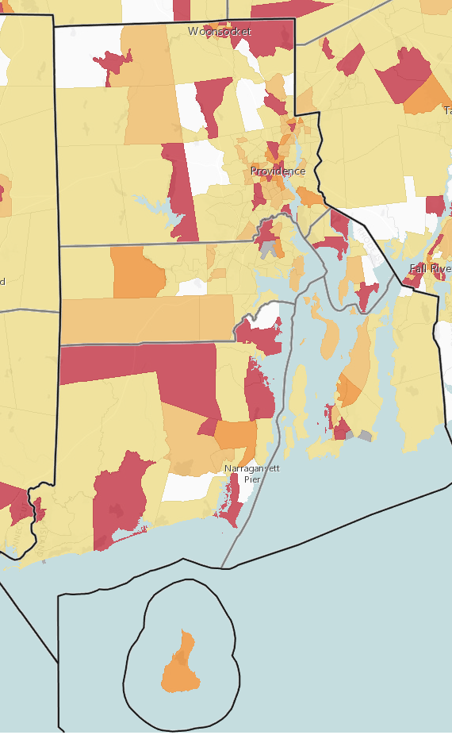  Latinx Population Below the Poverty Level by Census Tract

Latinx residents have similar pockets of disparity in Providence and Washington County. The disparity among Latinx residents within the Providence, Central Falls, and Pawtucket regions is greater than that among Blacks/African Americans. There is also greater disparity among Latinxs in the area of West Warwick in Kent County.

Rhode Island and the nation have equivalent white collar and blue collar work forces and unemployment rates. Kent county has a greater proportion of white collar workers compared to the state and the nation. Compensation for white collar workers tends to include benefits like private health insurance more often than it does for blue collar workers. Washington County also has a very low unemployment rate at 2.8%. Providence County has the highest blue collar workforce and unemployment rate, both of which are greater than the state and national percentages.

Population by Occupation and Unemployment
 | White Collar Workforce | Blue Collar Workforce | Unemployment Rate
Bristol County | 69.0% | 31.0% | 4.1%
Kent County | 63.0% | 37.0% | 4.9%
Newport County | 65.0% | 35.0% | 3.4%
Providence County | 58.0% | 42.0% | 5.9%
Washington County | 66.0% | 34.0% | 2.8%
Rhode Island | 61.0% | 39.0% | 5.0%
United States | 61.0% | 39.0% | 4.8%
Source: ESRI, 2018

Housing Measures
Homeownership and housing affordability are measures of economic stability. The median home values for Rhode Island and all five counties are higher than the national median. Kent County residents are more likely to own their home when compared to the state and the nation, while Providence County residents are more likely to rent their home.

Housing cost burden is defined by the US Census Bureau as spending more than 30% of household income on rent or mortgage expenses. Housing cost-burdened households are more likely to have difficulty affording other necessities like food, transportation, and medical care.

Half of all renters and about one-third of homeowners in Rhode Island are considered housing cost burdened. While housing cost burden in Kent and Providence counties is consistent with the state and the nation for renters, more homeowners are considered housing cost burdened compared to the nation. Providence County has the highest percentage of housing cost-burdened homeowners in the state.

Population by Household Type and Housing Cost Burden
 | Renter-Occupied | Renters Paying 30% or More of Income on Rent | Owner-Occupied | Median Home Value | Mortgages Costing 30% or More of Household Income
Bristol County | 29.7% | 53.5% | 70.3% | $330,000 | 31.7%
Kent County | 29.9% | 49.4% | 70.1% | $208,400 | 33.8%
Newport County | 39.1% | 47.4% | 60.9% | $352,900 | 35.3%
Providence County | 47.1% | 51.2% | 52.9% | $209,800 | 35.9%
Washington County | 27.6% | 50.3% | 72.4% | $315,100 | 32.2%
Rhode Island | 40.3% | 50.7% | 59.7% | $238,200 | 34.6%
United States | 36.4% | 51.1% | 63.6% | $184,700 | 30.8%
Source: US Census Bureau, 2012–2016

The Rhode Island Comprehensive Housing Production and Rehabilitation Act of 2004 and Rhode Island Low and Moderate Income Housing Act (Rhode Island General Laws 45-53) require that 10% of each municipality’s housing stock be "affordable." Twenty-nine communities are covered by the Act; ten are exempt due to their percentage of rental housing and/or current affordable housing inventory. The following table indicates the availability of low- and moderate-income housing for Rhode Island by target demographic.

Low and Moderate Income Housing (LMIH) Units by Target Demographic
 | Total LMIH Units | Total Housing Units | LMIH Percent of Total | Elderly Housing Units | Family Housing Units | Special Needs Housing Units
Rhode Island | 37,157 | 445,902 | 8.3% | 19,631  (53%) | 13,726  (37%) | 3,800  (10%)
Source: State of Rhode Island Office of Housing and Community Development, 2017

Each year, the Rhode Island Coalition for the Homeless conducts a point-in-time study to identify individuals experiencing homelessness. The unduplicated statewide count is conducted on a single night in January. The study does not include individuals at risk of homelessness or those who are “couch surfing.”

In 2018, 1,101 people across Rhode Island were identified as homeless, including 747 single adults and 354 persons in families. Of the single adults, nearly 75% were in emergency shelters and 19% were in transitional housing. Family households were more evenly split between emergency shelters (51%) and transitional housing (48%). Single adults were more likely than persons in families were to be unsheltered.

The vast majority (94%) of the chronically homeless population were in emergency shelters; 6% were unsheltered. Veterans were the most likely to be in transitional housing (61%), while youth were the most likely to be in emergency shelters (73%).

Homeless Point in Time Count
 | Single Adults |  | Persons in Families
 | Count | Percent | Count | Percent
Emergency Shelter | 557 | 74.6% | 182 | 51.4%
Transitional Housing | 141 | 18.9% | 170 | 48.0%
Unsheltered | 49 | 6.6% | 2 | 0.6%
Source: Rhode Island Coalition for the Homeless, 2018

Homeless Point in Time Count by Subpopulation
 | Chronically Homeless |  | Veterans |  | Youth
 | Count | Percent | Count | Percent | Count | Percent
Emergency Shelter | 247 | 93.6% | 37 | 35.9% | 40 | 72.7%
Transitional Housing | 0 | 0.0% | 63 | 61.2% | 14 | 25.5%
Unsheltered | 17 | 6.4% | 3 | 2.9% | 1 | 1.8%
Source: Rhode Island Coalition for the Homeless, 2018

The Rhode Island Department of Health defines homeless children as children under age 18 who stayed at homeless shelters, domestic violence shelters, or transitional housing facilities with their families. Across Rhode Island in 2017, 539 families with 998 children stayed at a homeless shelter or other emergency housing facility. Children comprised 22% of all homeless individuals in Rhode Island, 51% of whom were under age 6. The following tables depict homeless children identified by public schools during the 2016–2017 school year.

Homeless Children Identified during the 2016–2017 School Year
 | Total Student Enrollment | Number of Children Identified as Homeless
Four Core Cities | 41,419 | 444
Remainder of Rhode Island | 91,811 | 770
All of Rhode Island | 142,142 | 1,245
Source: Rhode Island Department of Health, 2016–2017

Homeless Children in the Core Cities Identified during the 2016–2017 School Year
 | Total Student Enrollment | Number of Children Identified as Homeless | Percent of Children Identified as Homeless
Central Falls | 2,589 | 63 | 2.4%
Pawtucket | 8,984 | 63 | 0.7%
Providence | 23,983 | 227 | 0.9%
Woonsocket | 5,863 | 91 | 1.6%
Source: Rhode Island Department of Health, 2016–2017

Education Measures
Education is the largest predictor of poverty and one of the most effective means of reducing inequalities. Rhode Island has a greater proportion of residents attaining a bachelor’s degree or higher and fewer residents who do not complete high school than the nation.

Kent County statistics are consistent with Rhode Island. In Providence County, the proportion of residents who have not completed high school is higher than Rhode Island and the US. A higher proportion of Providence County residents have completed a high school diploma/GED, while fewer residents have attained a bachelor’s degree or higher.

Population (25 Years or Over) by Educational Attainment
 | Less than a High School Diploma | High School Graduate/GED | Bachelor’s Degree or Higher
Bristol County | 7.9% | 20.3% | 49.5%
Kent County | 7.1% | 28.0% | 34.5%
Newport County | 5.7% | 22.1% | 48.5%
Providence County | 14.2% | 29.6% | 30.0%
Washington County | 5.2% | 22.2% | 47.5%
Rhode Island | 10.9% | 27.4% | 35.3%
United States | 12.3% | 27.0% | 31.8%
Source: ESRI, 2018

The following tables profile educational attainment by race and ethnicity. Across Rhode Island, minority populations are more likely to be impacted by adverse social determinants of health when compared to Whites.

Providence County has the greatest racial and ethnic diversity within the state, as well as some of the greatest socioeconomic disparity among minority populations. Education attainment is closely linked with poverty and socioeconomic disparity. In Providence County, one in four Black/African American residents and one in three Latinx residents live in poverty compared to approximately one in 10 White residents. Less than one in five Black/African American or Latinx residents have attained a bachelor’s degree or higher compared to nearly one in three White residents.

Bachelor’s Degree or Higher by Race and Ethnicity
 | White |  | Black/African American |  | Latinx
 | Count | Percentage | Count | Percentage | Count | Percentage
Bristol County | 15,194 | 46.2% | 174 | 43.1% | 290 | 45.3%
Kent County | 35,497 | 31.4% | 605 | 33.3% | 1,001 | 28.8%
Newport County | 25,242 | 46.1% | 594 | 34.3% | 700 | 33.8%
Providence County | 96,947 | 29.3% | 6,553 | 18.4% | 7,615 | 10.8%
Washington County | 36,661 | 45.3% | 242 | 30.1% | 614 | 37.6%
Rhode Island | 209,541 | 34.2% | 8,168 | 20.2% | 10,220 | 13.1%
Source: US Census Bureau, 2012–2016

Service Area Zip Code Analysis
Zip code of residence is one of the most important predictors of health disparity; where residents live matters in determining their health. The Community Need Index (CNI) was developed by Dignity Health and Truven Health Analytics to illustrate the potential for health disparity at the zip code level. The CNI scores zip codes on a scale of 1.0 (low need) to 5.0 (high need) based on 2015 data indicators for five socio-economic barriers:

- Income: Poverty among elderly households, families with children, and single female-headed families with children
- Culture/Language: Minority populations and English language barriers
- Education: Population over 25 years without a high school diploma
- Insurance coverage: Unemployment rate among population 16 years or over and population without health insurance
- Housing status: Householders renting their home

The weighted average CNI score for CharterCARE’s primary service area is 3.5, indicating higher overall community need.

Community Needs Index for CharterCARE’s Primary Service Area
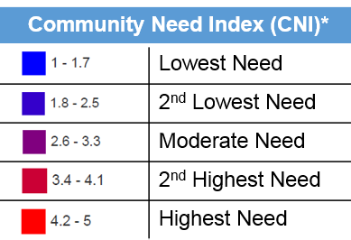
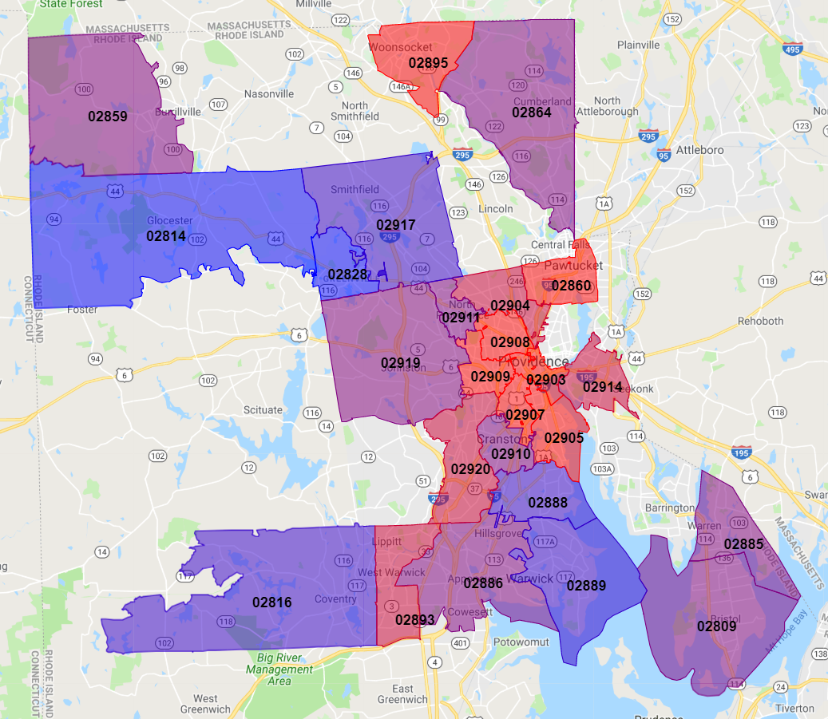

The following tables list the social determinants of health contributing to zip code CNI scores. Zip codes are shown in comparison to their respective county and the state, and are presented in descending order by CNI score. Cells highlighted in yellow are more than 2% points higher than the county statistic. Note: The 2% point difference does not represent statistical significance.

Social Determinants of Health Indicators by Zip Code
 | HHs in Poverty | HHs Receiving Food Stamps/ SNAP | Children in Poverty | Language Other than English Spoken at Home | Unemp- loyment | Less than HS Diploma | Without Health Insurance | CNI Score
Bristol County | 8.2% | 8.2% | 6.7% | 12.1% | 4.1% | 7.9% | 5.3% | 2.4
02885 (Warren) | 11.3% | 13.4% | 19.1% | 11.9% | 5.4% | 8.8% | 8.2% | 3.0
02809 (Bristol) | 9.9% | 9.8% | 7.2% | 14.2% | 4.3% | 10.9% | 6.3% | 2.8
Kent County | 9.7% | 12.0% | 8.9% | 8.7% | 4.9% | 7.1% | 5.7% | 2.4
02893 (West Warwick) | 17.3% | 19.5% | 19.4% | 10.5% | 4.9% | 10.2% | 7.2% | 3.4
02886 (Warwick) | 9.5% | 12.8% | 8.4% | 10.1% | 4.4% | 7.3% | 4.7% | 2.8
02889 (Warwick) | 7.5% | 12.0% | 7.7% | 8.0% | 5.0% | 7.8% | 5.9% | 2.4
02888 (Warwick) | 9.5% | 10.5% | 3.2% | 12.4% | 4.8% | 7.3% | 6.7% | 2.2
02816 (Coventry) | 8.1% | 10.9% | 10.6% | 5.3% | 6.3% | 6.9% | 5.0% | 1.8
Providence County | 17.3% | 20.5% | 24.4% | 30.5% | 5.9% | 14.2% | 9.6% | 3.5
02907 (Providence) | 28.7% | 45.7% | 36.3% | 69.0% | 11.2% | 25.0% | 19.9% | 4.8
02905 (Providence) | 24.9% | 31.5% | 37.9% | 48.2% | 9.7% | 15.8% | 12.9% | 4.8
02903 (Providence) | 35.7% | 26.7% | 22.7% | 32.3% | 6.2% | 17.1% | 11.1% | 4.8
02909 (Providence) | 35.3% | 44.2% | 42.6% | 64.8% | 10.1% | 33.4% | 20.5% | 4.8
02860 (Pawtucket) | 24.0% | 31.5% | 36.2% | 47.9% | 8.4% | 19.9% | 13.4% | 4.4
02908 (Providence) | 22.6% | 27.0% | 30.8% | 42.5% | 6.6% | 16.8% | 11.4% | 4.4
02895 (Woonsocket) | 24.6% | 28.3% | 38.5% | 24.6% | 4.3% | 17.2% | 9.4% | 4.2
02914 (East Providence) | 15.0% | 18.8% | 17.1% | 34.7% | 6.4% | 20.2% | 10.9% | 4.0
02904 (Providence) | 23.1% | 21.9% | 24.4% | 29.1% | 5.0% | 11.5% | 8.9% | 4.0
02920 (Cranston) | 12.0% | 11.1% | 17.8% | 24.2% | 5.5% | 10.6% | 6.9% | 3.6
02911 (North Providence) | 11.3% | 16.2% | 9.8% | 17.6% | 4.0% | 7.8% | 4.7% | 3.2
02919 (Johnston) | 9.1% | 13.8% | 13.6% | 15.5% | 3.8% | 10.2% | 3.8% | 3.0
02910 (Cranston) | 11.3% | 10.9% | 14.1% | 29.4% | 7.1% | 9.7% | 7.3% | 3.0
02859 (Pascoag) | 10.9% | 12.3% | 18.9% | 3.5% | 5.0% | 8.4% | 7.8% | 2.8
02864 (Cumberland) | 8.8% | 9.2% | 11.0% | 14.9% | 2.7% | 8.3% | 3.4% | 2.6
02917 (Smithfield) | 6.2% | 8.6% | 0.6% | 8.6% | 3.7% | 5.6% | 4.3% | 1.8
02828 (Greenville) | 4.6% | 3.5% | 2.2% | 6.0% | 4.8% | 6.8% | 2.7% | 1.6
02814 (Chepachet) | 4.6% | 8.7% | 10.1% | 3.8% | 3.4% | 5.0% | 6.2% | 1.4
Rhode Island | 14.1% | 16.1% | 18.9% | 21.6% | 5.0% | 10.9% | 8.0% | 3.1
Demographic Indicators by Zip Code
 | White | Black/ African American | Latinx | 18-24 | 25-34 | 35-44 | 45-54 | 55-64 | 65+
Bristol County | 93.7% | 1.2% | 3.2% | 11.0% | 10.5% | 10.1% | 14.2% | 15.8% | 20.3%
02885 (Warren) | 94.2% | 1.8% | 3.0% | 7.3% | 12.7% | 11.4% | 14.4% | 16.0% | 21.2%
02809 (Bristol) | 94.6% | 1.3% | 3.3% | 15.6% | 12.1% | 10.1% | 12.0% | 14.3% | 21.3%
Kent County | 91.1% | 1.9% | 5.1% | 7.2% | 12.4% | 12.3% | 14.5% | 15.7% | 19.6%
02893 (West Warwick) | 88.2% | 2.9% | 7.9% | 7.5% | 14.9% | 14.3% | 12.9% | 14.0% | 17.2%
02886 (Warwick) | 90.1% | 2.1% | 5.6% | 6.8% | 12.4% | 12.2% | 13.4% | 14.7% | 24.1%
02889 (Warwick) | 90.3% | 2.3% | 5.3% | 7.5% | 12.9% | 12.7% | 14.7% | 16.4% | 18.0%
02888 (Warwick) | 89.4% | 2.6% | 6.0% | 7.1% | 12.7% | 12.5% | 14.4% | 16.1% | 20.1%
02816 (Coventry) | 95.0% | 0.9% | 3.2% | 7.4% | 11.9% | 11.4% | 15.9% | 15.9% | 18.9%
Providence County | 68.7% | 9.5% | 23.4% | 11.7% | 14.2% | 12.1% | 12.8% | 12.9% | 16.1%
02907 (Providence) | 23.9% | 23.7% | 63.9% | 12.0% | 17.6% | 12.3% | 11.7% | 10.2% | 8.8%
02905 (Providence) | 45.4% | 19.6% | 42.9% | 17.0% | 15.4% | 10.7% | 11.4% | 11.1% | 11.4%
02903 (Providence) | 54.9% | 13.8% | 23.0% | 35.1% | 19.0% | 8.5% | 7.7% | 8.2% | 14.3%
02909 (Providence) | 35.9% | 14.3% | 63.8% | 13.7% | 19.2% | 13.0% | 10.8% | 8.4% | 7.6%
02860 (Pawtucket) | 50.5% | 20.0% | 31.4% | 9.9% | 15.8% | 13.0% | 12.9% | 12.0% | 13.2%
02908 (Providence) | 49.9% | 17.9% | 40.5% | 20.6% | 15.9% | 12.0% | 10.3% | 9.1% | 10.2%
02895 (Woonsocket) | 71.5% | 7.9% | 19.7% | 8.9% | 14.3% | 12.6% | 12.6% | 12.9% | 15.9%
02914 (East Providence) | 72.6% | 10.1% | 8.6% | 7.9% | 14.5% | 13.0% | 12.8% | 12.9% | 19.4%
02904 (Providence) | 66.5% | 13.2% | 20.3% | 8.4% | 14.1% | 12.2% | 12.2% | 13.5% | 21.8%
02920 (Cranston) | 75.4% | 7.3% | 17.1% | 8.6% | 14.4% | 12.8% | 13.3% | 13.5% | 21.0%
02911 (North Providence) | 83.0% | 5.6% | 12.7% | 7.9% | 14.5% | 13.2% | 13.9% | 14.2% | 19.3%
02919 (Johnston) | 87.7% | 3.0% | 9.9% | 7.1% | 12.7% | 11.8% | 14.1% | 15.2% | 21.9%
02910 (Cranston) | 71.0% | 7.3% | 18.3% | 8.4% | 14.8% | 13.5% | 13.5% | 14.0% | 15.7%
02859 (Pascoag) | 94.7% | 1.0% | 3.5% | 7.7% | 11.5% | 12.7% | 16.2% | 16.4% | 15.8%
02864 (Cumberland) | 90.0% | 2.0% | 6.8% | 7.2% | 11.2% | 12.1% | 15.1% | 15.4% | 18.9%
02917 (Smithfield) | 93.0% | 1.9% | 3.9% | 24.7% | 8.1% | 9.2% | 12.6% | 14.1% | 17.6%
02828 (Greenville) | 95.6% | 1.2% | 2.5% | 7.1% | 8.5% | 10.3% | 14.2% | 16.6% | 26.3%
02814 (Chepachet) | 96.3% | 0.5% | 2.3% | 7.2% | 9.8% | 11.8% | 17.4% | 18.4% | 16.6%
Rhode Island | 77.8% | 6.5% | 15.9% | 10.9% | 13.0% | 11.7% | 13.3% | 14.1% | 17.7%

Secondary Data Profile Background and Methodology

Background
Health indicators were analyzed for a number of health issues, including access to care, health behaviors and outcomes, chronic disease prevalence and mortality, mental health and substance use disorder, and maternal and child health. Data were compiled from secondary sources including the Rhode Island Department of Health, the Centers for Disease Control and Prevention (CDC), the Behavioral Risk Factor Surveillance System (BRFSS), Youth Risk Behavior Surveillance System (YRBSS), and the University of Wisconsin County Health Rankings & Roadmaps program, among other sources. A comprehensive list of data sources is provided in Appendix A.

Health data focus on county-level reporting which is generally the most recent and most consistent data available. Health data for the counties are compared to state and national averages and Healthy People 2020 (HP 2020) goals, where applicable, to provide benchmark comparisons. Healthy People is a US Department of Health and Human Services health promotion and disease prevention initiative that sets science-based, 10-year national objectives for improving the health of all Americans.

Age-adjusted rates are referenced throughout the reporting to depict a comparable burden of disease among residents. Age-adjusted rates are summary measures adjusted for differences in age distributions so that data from one year to another, or between one geographic area and another, can be compared as if the communities reflected the same age distribution.

The BRFSS is a telephone survey of residents age 18 or over conducted nationally by states as required by the CDC. A consistent survey tool is used across the US to assess health risk behaviors, prevalence of chronic health conditions, access to care, and preventive health measures, among other health indicators. BRFSS results included within this report were provided by the Rhode Island Department of Health.

The YRBSS is a school-based survey conducted by the CDC every other odd year to monitor priority health risk behaviors among youth. YRBSS findings are reported for youth in grades
9–12 by county.

The most recent data available at the time of this study were used unless otherwise noted.

Access to Healthcare
Rhode Island counties are shown in rank order for clinical care, as reported by the University of Wisconsin County Health Rankings & Roadmaps program. The rankings are based on a number of indicators, including health insurance coverage and provider access and have not changed since 2015 reporting.

2018 Clinical Care County Health Rankings

#1 Bristol County (#1 in 2015)
#2 Washington County (#2 in 2015)
#3 Newport County (#3 in 2015)
#4 Kent County (#4 in 2015)
#5 Providence County (#5 in 2015)

Health Insurance Coverage
Rhode Island has proportionately fewer people uninsured than the nation.
The percent of uninsured dropped 7 points from
2012 to 2016.
The State of Rhode Island has fewer uninsured residents compared to the nation; however, no counties meet the Healthy People 2020 goal of having 100% of all residents insured. Providence County has the highest percent uninsured, but the percentage is still lower than the nation by 2% points.

Over the past five years, the percentage of uninsured residents declined, though there was a slight increase between 2015 and 2016 in Washington County. Providence County experienced the greatest decline of 8% points between 2012 and 2016.

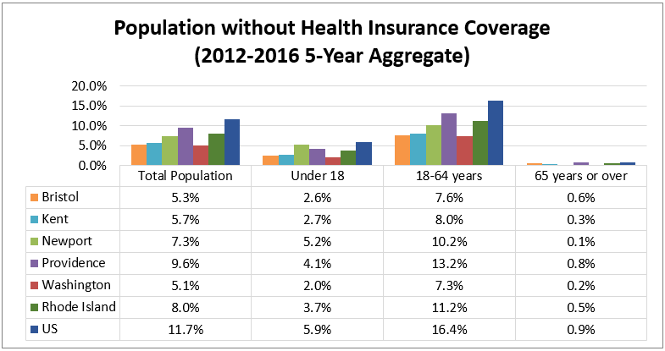
Source: US Census Bureau, 2012–2016

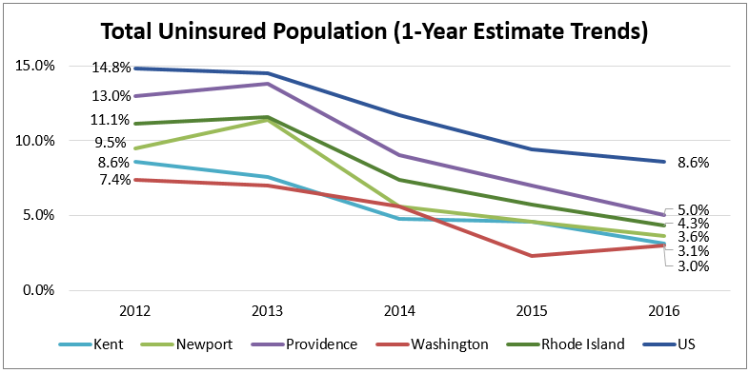
Source: US Census Bureau, 2012–2016
*The Bristol County uninsured rate is all reported as a five-year aggregate based on data availability.

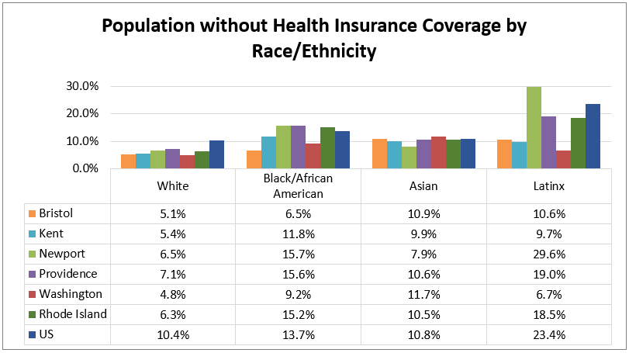
Source: US Census Bureau, 2012–2016

Uninsured percentages across Rhode Island and the nation are highest among Latinx residents. Providence County is consistent with the state and the nation in this way. However, in Kent and Washington counties, the percent uninsured is highest among Blacks/African Americans and Asians respectively.
A higher percentage of Providence County residents are insured by Medicaid
The following graph depicts health insurance coverage by type of insurance. Residents of Rhode Island and all of the counties are most likely to be covered by employer-based insurance. A higher percentage of residents in Providence County are covered by Medicaid insurance.

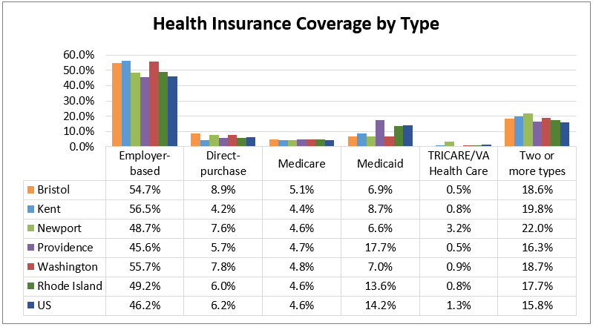
Source: US Census Bureau, 2012–2016

Provider Access
Provider rates are measured as the number of providers in an area per 100,000 people, and are measured against state and national benchmarks for primary care physicians, dentists, and mental health care providers. Primary care physicians include non-federal, practicing physicians under age 75 specializing in general practice medicine, family medicine, internal medicine, and pediatrics. Mental health providers include psychiatrists, psychologists, licensed clinical social workers, counselors, marriage and family therapists, mental health providers that treat alcohol and other drug abuse, and advanced practice nurses specializing in mental health care.
From 2011 to 2015, the Providence County primary care provider rate per 100,000 people increased by 4 points.

All Rhode Island counties have a higher primary care physician rate than the nation, indicating a greater number of providers per person and potential for greater access to care.
The Kent and Providence County provider rates increased from 2011 to 2015 by 9 points 4 points respectively. The Washington County rate declined 2 points during the same time period.

Rhode Island has a lower dentist provider rate than the nation, indicating fewer dentists per person. However, the dentist provider rate increased 3–4 points from 2012 to 2016 across Rhode Island and in Kent, Providence, and Washington counties. Kent County has a higher dentist provider rate than the state and the nation.
The mental health care provider rate increased by 61 points in Providence County between 2014 and 2017.

Rhode Island has a higher mental health provider rate than the nation. The statewide provider rate increased more than 50 points from 2014 to 2017. The rate also increased in Kent, Providence, and Washington counties. Providence County saw the greatest provider rate increase of 61 points; the current rate for the county is the highest in the state. These findings indicate overall improved access to care, but may not account for specialty provider shortages, including psychiatrists and psychologists.

Provider Rates per 100,000
(Green = Higher than the State or Nation; Red = Lower than the State or Nation)
 | 2015 Primary Care Physician Rate | 2016 Dentist Provider Rate | 2017 Mental Health Care Provider Rate
Bristol County | 181.3 | 36.7 | 185.5
Kent County | 80.1 | 72.9 | 281.3
Newport County | 84.9 | 95.4 | 302.0
Providence County | 95.3 | 60.1 | 433.0
Washington County | 92.5 | 55.4 | 285.1
Rhode Island | 95.8 | 63.2 | 370.2
United States | 75.8 | 67.6 | 212.8
Source: Health Resources & Services Administration, 2015 & 2016; Centers for Medicare and Medicaid Services, 2017
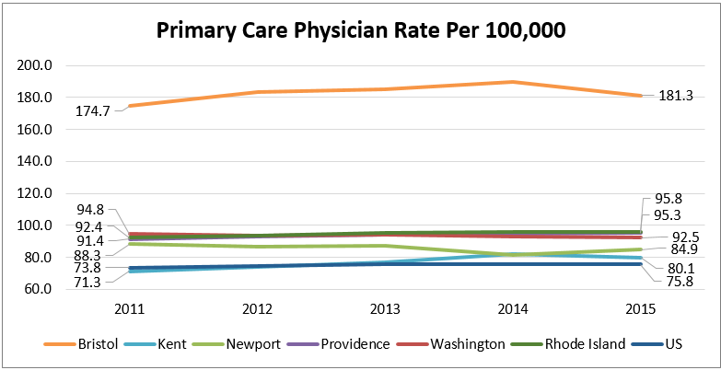
Source: Health Resources & Services Administration, 2011–2015
*Primary care physicians are identified based on the county in which their preferred professional/business mailing address is located. Rates do not take into account providers that serve multiple counties or satellite clinics.

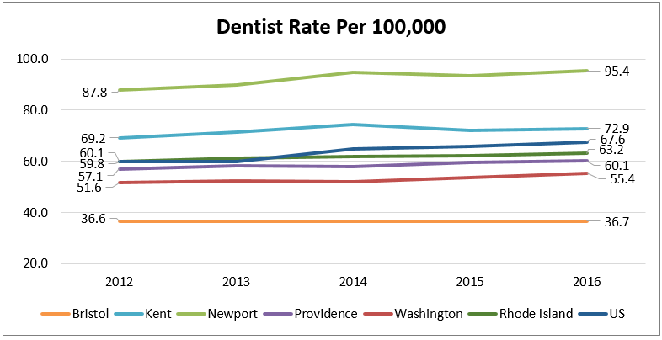
Source: Health Resources & Services Administration, 2012–2016

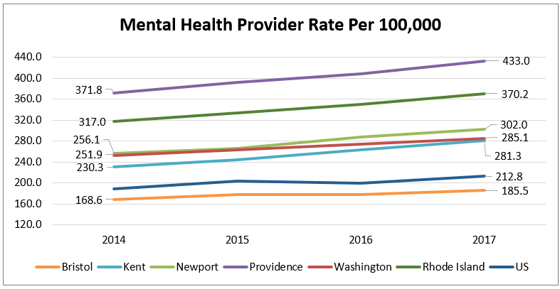
Source: Centers for Medicare and Medicaid Services, 2014–2017
*An error occurred in the County Health Rankings method for identifying mental health providers in 2013. Data prior to 2014 are not shown.

The Health Resources & Services Administration is responsible for designating geographic areas as Health Professional Shortage Areas (HPSAs) for primary, dental, and mental health care. Shortage areas are determined based on a defined ratio of total health professionals to total population. The following HPSAs are located within Rhode Island:
Newport, Providence, and Washington counties are HPSAs for mental health care

Health Professional Shortage Areas in Rhode Island
Newport County:
- All of Newport County: Mental health HPSA
- Newport/Middletown Area: Dental health HPSA for low-income populations

Providence County:
- All of Providence County: Mental health HPSA for low-income populations
- Four Core Cities (Central Falls, Pawtucket, Providence, and Woonsocket): Primary care and dental health HPSA for low-income populations

Washington County:
- All of Washington County: Mental health HPSA
- New Shoreham: Primary care HPSA

The Health Resources & Services Administration also plays a role in designating Federally Qualified Health Centers (FQHCs). Federally Qualified Health Centers are defined as “community-based health care providers that receive funds from the HRSA Health Center Program to provide primary care services in underserved areas.” Services are provided on a sliding fee scale based on patient ability to pay. The following map identifies the location of primary and dental care HPSAs and FQHCs across the state. A list of FQHC locations is provided in Appendix B.

Health Professional Shortage Area and Federally Qualified Health Center Locations
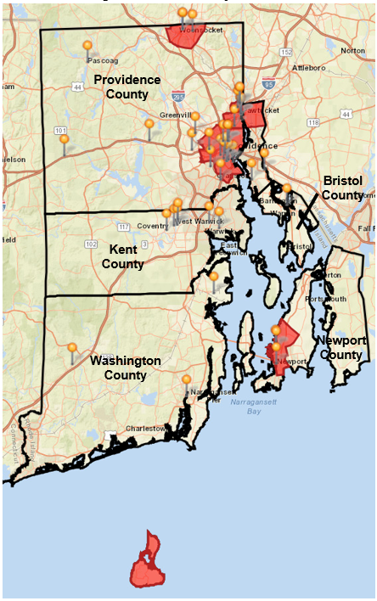
Health Professional Shortage Areas (HPSA)
Federally Qualified Health Center (FQHC)
Routine Health Care Access
Health insurance coverage and provider availability can impact the number of residents who have a primary care provider and receive routine care. Rhode Island adults are more likely to have a usual primary care provider and receive routine checkups, and are less likely to consider cost as a barrier to receiving care. Providence County adults are more likely to consider cost as a barrier to receiving care than other Rhode Islanders.
Providence County adults are more likely to consider cost as a barrier to receiving care than other Rhode Islanders

Adult Routine Health Care Access
(Green/Red = Higher than the State or Nation)
 | Has a Personal Doctor | Received a Routine Checkup within the Past 2 Years | Unable to See a Doctor within the Past Year due to Cost
Bristol County | 92.7% | 96.9% | 6.7%
Kent County | 88.7% | 94.1% | 5.9%
Newport County | 87.5% | 89.2% | 6.5%
Providence County | 86.0% | 91.8% | 12.3%
Washington County | 90.2% | 90.5% | 8.7%
Rhode Island | 87.2% | 92.0% | 10.3%
United States | 77.1% | 83.6% | 12.0%
Source: Centers for Disease Control and Prevention, 2016; Rhode Island Department of Health, 2016

Overall Health Status
Rhode Island counties received the following health outcomes rankings, as reported by the University of Wisconsin County Health Rankings & Roadmaps program. Health outcomes are measured in relation to premature death (before age 75) and quality of life. The rankings are unchanged since the 2016 CHNA.

2018 Health Outcomes County Health Rankings

#1 Bristol County (#1 in 2015)
#2 Newport County (#2 in 2015)
#3 Washington County (#3 in 2015)
#4 Kent County (#4 in 2015)
#5 Providence County (#5 in 2015)

Kent and Providence counties, ranking No. 4 and No. 5 respectively for health outcomes, have a higher premature death rate than the state. Providence County adults are also more likely to self-report having “poor” or “fair” health status, and a higher average of poor physical and mental health days. Health care access barriers, including provider availability and adults who receive timely care, may impact the findings for Providence County.
Rhode Island adults are more likely to receive routine care, however, a higher percentage of Providence County residents delay care due to cost

Health Outcomes Indicators
(Green = Lower than the State or Nation; Red = Higher than the State or Nation)
 | Premature Death Rate per 100,000 | Adults with “Poor” or “Fair” Health Status | 30-Day Average - Poor Physical Health Days | 30-Day Average - Poor Mental Health Days
Bristol County | 4,599 | 10.2% | 3.4 | 3.7
Kent County | 6,042 | 11.9% | 3.6 | 4.1
Newport County | 4,484 | 11.0% | 3.3 | 3.5
Providence County | 6,284 | 16.5% | 4.0 | 4.4
Washington County | 5,424 | 11.3% | 3.4 | 3.9
Rhode Island | 5,920 | 14.8% | 3.8 | 4.3
United States | 6,700 | 16.0% | 3.7 | 3.8
Source: National Center for Health Statistics, 2014–2016; Centers for Disease Control and Prevention, 2016

Life expectancy increased across the state and all counties by approximately one year from 2005 to 2014. Kent and Providence County residents have the lowest life expectancies (79.3–79.4 years) of Rhode Island counties.

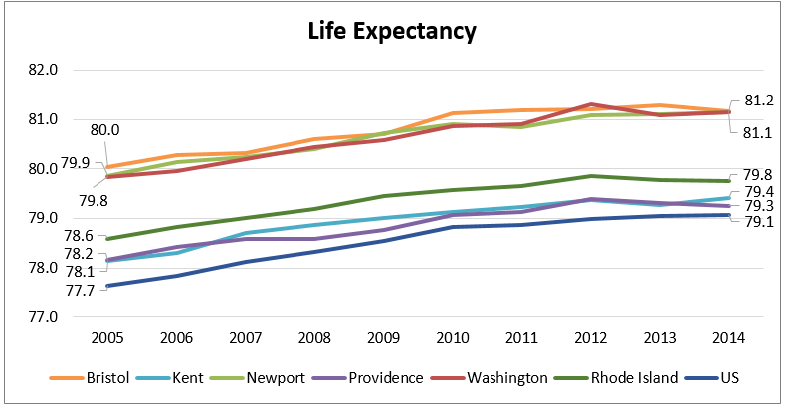 Source: Institute for Health Metrics and Evaluation, 2005–2014
The following maps depict life expectancy by census tract (CT) within each county, as available. Data are provided by the US Small-area Life Expectancy Estimates Project, a partnership of the National Center for Health Statistics, the Robert Wood Johnson Foundation, and the National Association for Public Health Statistics and Information Systems. All data are reported as a five-year aggregate for 2011–2015.
Kent and Providence counties have the lowest life expectancies and highest premature death rates in the state

Within Rhode Island, Bristol, Newport, and Washington counties have the greatest overall life expectancy of 75 years or greater. Within Kent and Providence counties, several areas have an average life expectancy of less than 75 years. These areas are concentrated in the core cities in Providence County and West Warwick in Kent County, where residents experience greater socioeconomic disparity and potential for health disparity. For each county, areas with an average life expectancy of less than 78 years are noted.

Bristol County Life Expectancy by Census Tract
Area of Disparity: Warren
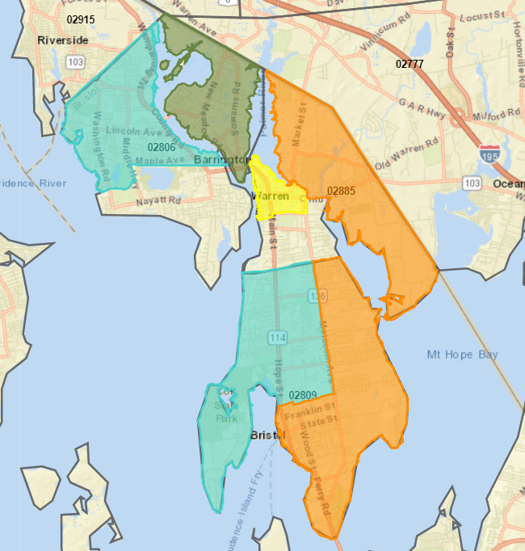
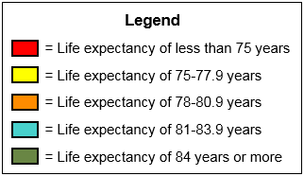

Kent County Life Expectancy by Census Tract
Areas of Disparity: Coventry, Warwick, West Greenwich, West Warwick
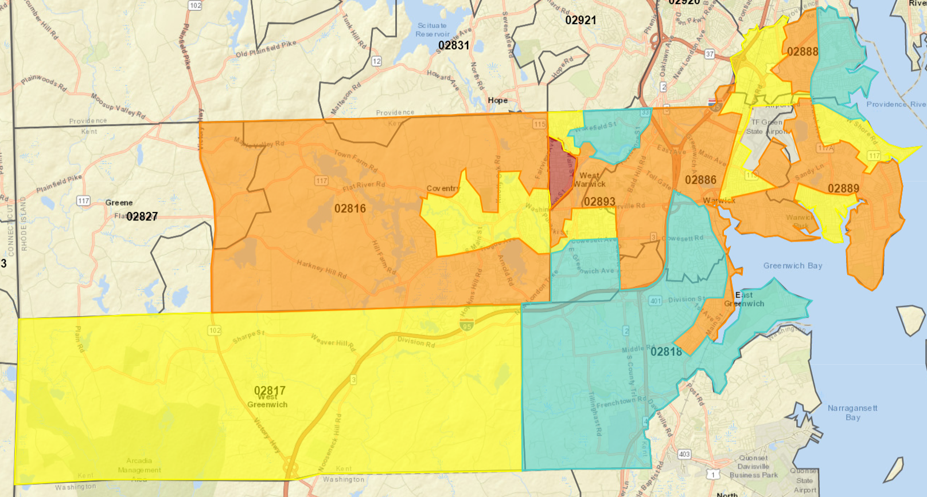

Newport County Life Expectancy by Census Tract
Areas of Disparity: Middletown, Newport
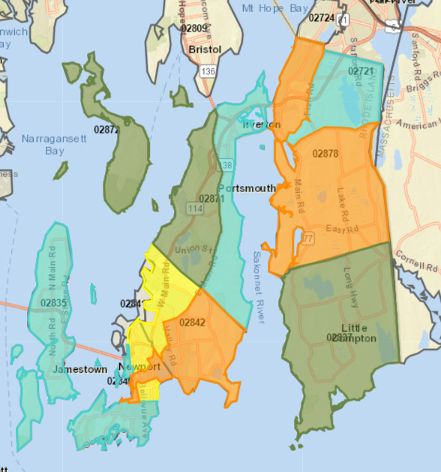

Providence County Life Expectancy by Census Tract
Areas of Disparity: Central Falls, Pawtucket, Providence, Smithfield, Woonsocket
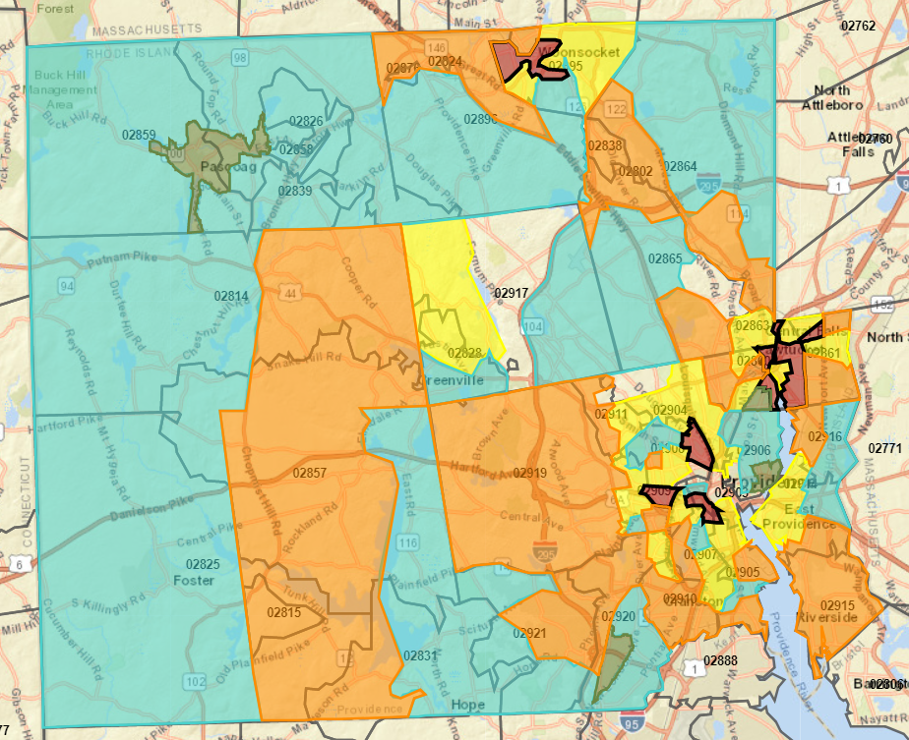

Washington County Life Expectancy by Census Tract
Areas of Disparity: South Kingstown, Westerly
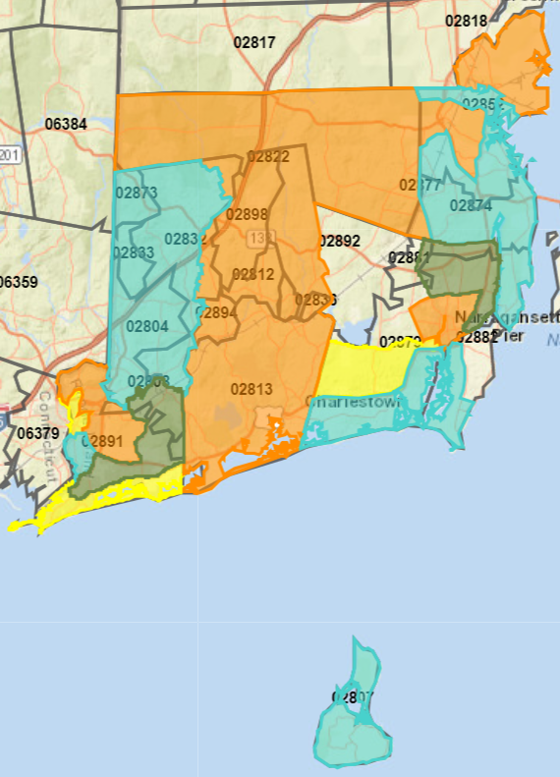
Health Behaviors
Health behaviors may increase or reduce the likelihood of disease or early death. Individual health behaviors include risk factors like tobacco use and obesity, or health promoting behaviors like exercise, good nutrition, and stress management. The prevalence of these health behaviors is provided below, with benchmark comparisons, as available.

Tobacco use
According to the CDC, tobacco use is the leading cause of preventable disease, disability, and death in the United States. Since 2012, smoking rates among adults declined across the state and in all counties except Kent and Newport. In Kent County, the percent of adults who reported smoking increased by one percentage point. In Newport County the percent increased by 6.5 percentage points. As a whole, Washington County adults are less likely to smoke when compared to the state and the nation, nearly meeting the Healthy People 2020 goal of 12% of the population.
Smoking Among Adults from the 2016 CHNA to Present
(Green = Decrease of More than 2 Points; Red = Increase of More than 2 Points)
 | 2012 | 2016
Bristol County* | 15.7% | 12.5%
Kent County | 16.1% | 17.3%
Newport County | 8.5% | 15.0%
Providence County | 19.3% | 15.4%
Washington County | 15.0% | 12.7%
Rhode Island | 17.4% | 14.4%
United States | 17.0% | 17.0%
Healthy People 2020 | 12.0% | 12.0%
Source: Centers for Disease Control and Prevention, 2012 & 2016; Healthy People 2020
*Bristol County data is reported for 2010 due to data availability. A change in methods occurred
in 2011 that may affect the validity of comparisons to prior years.

It is important to note that new trends related to e-cigarettes are affecting smoking data. Some traditional cigarette smokers have changed to e-cigarettes, while others who had never smoked before, particularly teens, are trying “vaping.” Data reflecting these trends were not available at the time of this report, but qualitative research indicated that “vaping” is a fast growing trend, especially among teens and young adults.
20% of RI high school students reported current use of e-cigarettes in 2017

E-cigarette use has surpassed traditional cigarette use among teens. According to the Rhode Island Department of Health, in 2017 26% of Rhode Island high school students reported using a form of tobacco (cigarettes or cigars, smokeless tobacco, or e-cigarettes) on at least one day during the past 30 days. In 2017, 20% of high school students reported current use of e-cigarettes, while 6% of students reported current use of traditional cigarettes.

Smoking among High School Students from the 2016 CHNA to Present
 | 2013 | 2017
Rhode Island | 8% | 6%
United States | 16% | 9%
Source: Rhode Island Department of Health; Centers for Disease Control and Prevention, 2013 & 2017

Additional data related to substance use among youth is included within the Youth Behavioral Health section of this report on page 55.

Adult Obesity
Obesity is associated with an increased risk of disease and mortality, as well as a reduced quality of life. Healthy People 2020 sets a goal of having no more than 30.5% of all adults obese. All Rhode Island counties have met the Healthy People 2020 goal, and fewer adults are obese when compared to national averages. However, current percentages still indicate that more than one in five adults living in Rhode Island are obese. Across Rhode Island, the percentage of obese adults increased since 2012.

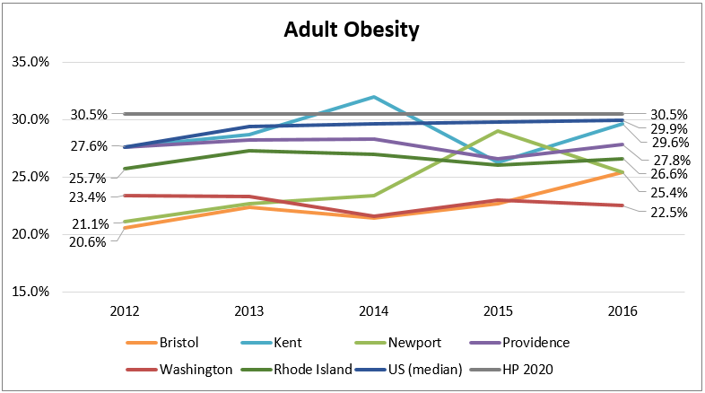
Source: Centers for Disease Control and Prevention, 2002–2016; Rhode Island Department of Health, 2012–2016

Adolescent Obesity
In 2017, 15% of Rhode Island high school students were obese and 16% were overweight. The percentage of obese students increased since 2007, while the percentage of overweight students has remained consistent. A higher percentage of Latinx students (21%), males (17%), and Black/African American students (18%) were obese compared to their peers.

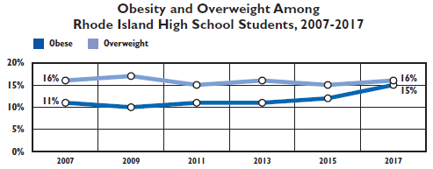
Source: Rhode Island Department of Health, 2007–2017

Physical Activity and Nutrition
Lifestyle habits such as regular exercise and good nutrition are important to maintaining health. Environments that foster these habits provide easy access to places where people can be active and obtain nutritious foods. Parks, gyms, pools, and recreation centers can encourage positive physical activity habits. Grocery stores, community gardens, farm stands, and mobile food markets make it easier for residents to obtain healthy foods.

Despite availability, other factors can influence residents’ ability to access these resources. Transportation, neighborhood safety, times of operation, cost, and other factors present barriers for some residents to take advantage of existing community assets.

As an example, 94% of Providence County residents live within close proximity of venues that promote physical activity; yet, the percentage of adults in Providence County that engage in physical activity is the lowest in the state. In contrast, Washington County residents are least likely to have access to physical activity venues, but are among the most likely to be physically active.

Residents in Providence County are more likely to experience higher socioeconomic needs, while residents in Washington County generally experience lower socioeconomic needs, which may account for the difference in physical activity, despite availability of resources.

Physical Activity
(Green = Higher than the State or Nation; Red = Lower than the State or Nation)
 | Access to Venues that Promote Physical Activity | Participated in Physical Activity  within the Past Month
Bristol County | 91.9% | 77.8%
Kent County | 94.0% | 78.8%
Newport County | 83.9% | 81.7%
Providence County | 94.0% | 72.2%
Washington County | 76.1% | 80.7%
Rhode Island | 91.0% | 75.6%
United States | 83.0% | 76.9%
Source: Business Analyst, Delorme Map Data, ESRI, & US Census Tigerline Files, 2010 & 2016; Centers for Disease Control and Prevention, 2016; Rhode Island Department of Health, 2016

Food insecurity is defined as being without a consistent source of sufficient and affordable nutritious food. Food insecurity is reflective of a variety of socioeconomic factors including employment, income, access to healthy food options, transportation, housing, and other factors.

Residents who are food insecure may also experience challenges with healthy eating and weight management. Acknowledging the relationship between socioeconomics and food insecurity, the percent of children eligible for free or reduced school lunch is shown in the table below along with the percentage of food insecure residents and children
Nearly 1 in 5
Providence County children are
food insecure
Nearly 20% of Providence County children are food insecure and nearly 60% of children are eligible for free or reduced school lunch. Eligibility for free school lunch includes households with an income at or below 130% of the poverty threshold. Households with an income between 130% and 185% of the poverty threshold are eligible for reduced priced school lunch.

Food Insecure Residents
(Red = Higher than the State or Nation)
 | All Residents | Children | Free or Reduced School Lunch Eligibility
Bristol County | 10.0% | 13.8% | 19.5%
Kent County | 10.4% | 15.1% | 31.6%
Newport County | 11.5% | 15.4% | 31.8%
Providence County | 13.2% | 19.1% | 58.6%
Washington County | 10.7% | 15.2% | 23.2%
Rhode Island | 12.1% | 17.4% | 47.0%
United States | 12.9% | 17.5%
Source: Feeding America, 2016; National Center for Education Statistics, 2015-2016

Mortality
The following graph depicts the all cause age-adjusted death rate by county and race/ethnicity. The overall death rate for all Rhode Island counties is lower than the national rate. The death rate for Providence County is higher than the state and similar to the nation. Minority populations often experience higher death rates. This does not appear to be the case for the majority of Rhode Island and may be due to the small minority population and low death counts.
The death rate for Providence County is higher than the state and similar to the nation

Minority populations often experience higher death rates. This does not appear to be the case for the majority of Rhode Island and may be due to the small minority population and low death counts.

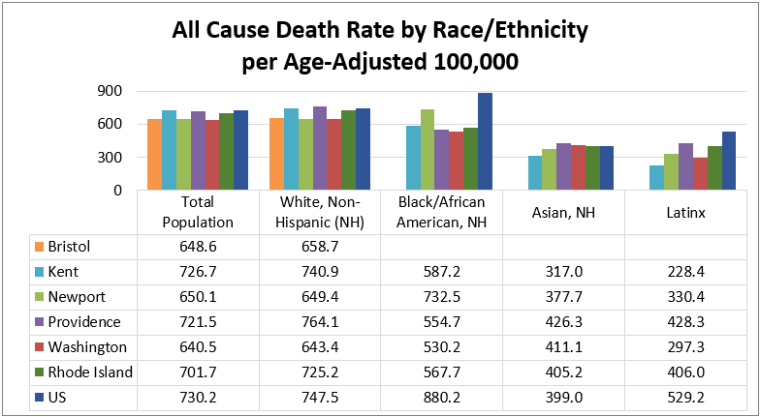
Source: Centers for Disease Control and Prevention, 2012-2016
*Data for Bristol County are reported as available due to low death counts.

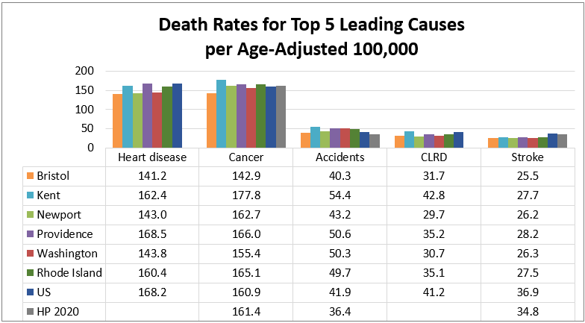
Source: Centers for Disease Control and Prevention, 2012–2016; Healthy People 2020

While heart disease remains the top cause of death in the nation, cancer is beginning to surpass heart disease as the top cause of death in some states, including Rhode Island. Cancer is the leading cause of death in all counties except Providence County, which has a higher rate of death due to heart disease.
Kent County has the highest rate of cancer deaths in the state, outpacing other counties, the state, the nation, and the Healthy People 2020 goal

Kent County has the highest rate of cancer deaths in the state, outpacing other counties, the state, the nation, and the Healthy People 2020 goal. Analysis of cancer mortality and morbidity is included within the chronic disease section of this report.

Accidents or unintentional injuries are the third leading cause of death in Rhode Island and the nation. Rhode Island has a higher accidental death rate than the nation and the state, and all five counties exceed the Healthy People 2020 goal for accidental deaths. Accidental deaths in rank order from highest cause of death in Rhode Island include accidental poisoning by and exposure to narcotics and psychodysleptics (hallucinogens), unspecified falls, accidental poisoning by and exposure to other and unspecified drugs, medicaments, and biological substances, unspecified motor-vehicle accidents, and accidental poisoning by and exposure to alcohol.

Chronic Diseases
Most top causes of death in Rhode Island fall under the broader category of chronic diseases, which are the leading causes for death and disease. Chronic diseases are often preventable through reduced risk behaviors like tobacco or alcohol use; regular physical activity; good nutrition; early detection of risk factors and disease, and effective disease management.

Heart Disease and Stroke
Between 2007 and 2016, death rates due to heart disease declined across the state and the nation. Heart disease death rates for all five counties fall below the national rate. Death rates for all five counties except Providence also fall below the state rate.

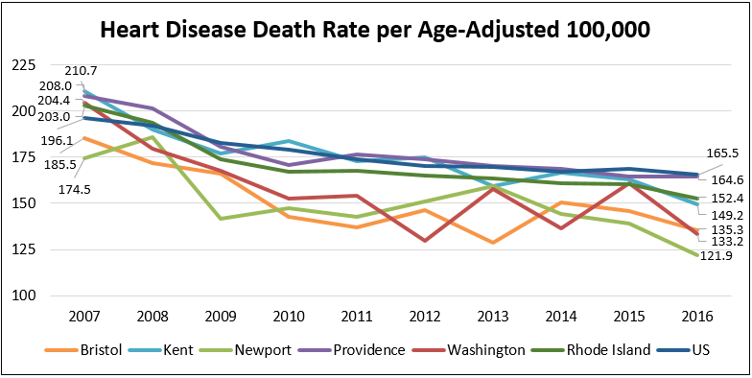
Source: Centers for Disease Control and Prevention, 2007–2016

Across the nation, the heart disease death rate is highest among Blacks/African Americans. Rhode Island as a whole differs from the national trend with a higher rate of death among Whites. Race and ethnicity data are not reported for all counties due to low death counts.

Heart Disease Death Rates per Age-Adjusted 100,000 by Race and Ethnicity
 | White, Non-Hispanic | Black/African American, Non-Hispanic | Latinx
Newport County | 141.2 | 206.6 | NA
Providence County | 178.2 | 121.0 | 84.8
Rhode Island | 165.4 | 126.8 | 80.6
United States | 170.9 | 212.6 | 118.2
Source: Centers for Disease Control and Prevention, 2012–2016
*Data for Bristol, Kent, and Washington counties are not reported due to low death counts.

Hypertension and high cholesterol can lead to heart disease. A higher percentage of Rhode Island adults have hypertension when compared to adults across the nation. Kent County, followed by Providence County adults have the highest prevalence of hypertension in the state. In contrast, a lower percentage of Rhode Island adults have high cholesterol when compared to adults across the nation.

Heart Disease Prevalence among Adults
(Green = Lower than the State or Nation; Red = Higher than the State or Nation)
 | Hypertension | High Cholesterol
Bristol County | 28.1% | 38.8%
Kent County | 36.5% | 34.9%
Newport County | 31.3% | 34.4%
Providence County | 32.5% | 35.9%
Washington County | 30.9% | 33.7%
Rhode Island | 32.4% | 35.2%
United States | 30.9% | 36.3%
Source: Centers for Disease Control and Prevention, 2015; Rhode Island Department of Health, 2015

Coronary heart disease is characterized by the buildup of plaque inside the coronary arteries. Rhode Island, Kent County, and Providence County do not meet the Healthy People 2020 goal for coronary heart disease death.
The Providence County coronary heart disease death rate is the highest in the state and higher than the nation

Several types of heart disease, including coronary heart disease, are risk factors for stroke. Rhode Island and all five counties meet the Healthy People 2020 goal for stroke death and have a lower rate of death than the nation.

Coronary Heart Disease and Stroke Death Rates
(Green = Lower than State or National Benchmarks;
Red = Higher than State or National Benchmarks)
 | Coronary Heart Disease Death per Age-Adjusted 100,000 | Stroke Death per Age-Adjusted 100,000
Bristol County | 97.0 | 25.5
Kent County | 115.4 | 27.7
Newport County | 89.0 | 26.2
Providence County | 117.1 | 28.2
Washington County | 93.2 | 26.3
Rhode Island | 110.1 | 27.5
United States | 99.6 | 36.9
Healthy People 2020 | 103.4 | 34.8
Source: Centers for Disease Control and Prevention, 2012–2016; Healthy People 2020

Cancer
Cancer is the second leading cause of death in America, but the top cause of death in Rhode Island. The age-adjusted overall incidence of cancer is higher among males than females.

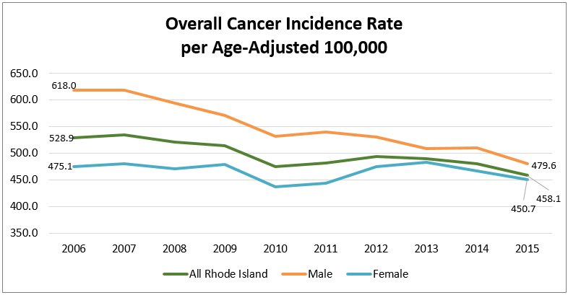
Source: Rhode Island Department of Health, 2006–2015
Rhode Island overall has higher incidence of lung cancer; Providence County has one of the highest incidence rates in the state
Presented below are the incidence rates for the most commonly diagnosed cancers: breast (female), colorectal, lung, and prostate (male). Rhode Island outpaces the nation for breast and lung cancer incidence; and Kent County rates exceed the state. Providence County has a higher incidence of lung cancer compared to the state and the nation, while Washington County has a higher incidence of breast cancer.

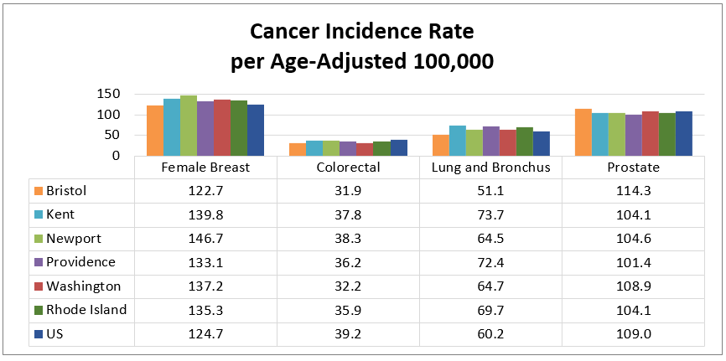
Source: Centers for Disease Control and Prevention, 2011–2015
Cancer death rates among Rhode Island counties have been variable over the past decade, but declined over the past decade. Death rates for all counties except Kent and Newport meet the Healthy People 2020 goal of 161.4 per age adjusted 100,000 people.
Cancer death rates declined over the past decade; Providence County meets HP2020 goals for all
cancer death rates except lung

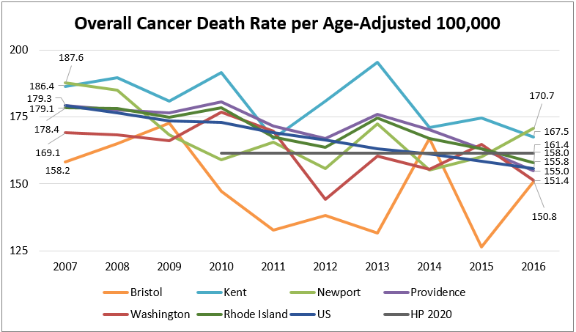
Source: Centers for Disease Control and Prevention, 2007–2016

Across the nation, Blacks/African Americans have a higher rate of cancer death than Whites do. However, across Rhode Island, Whites have a higher death rate than Blacks/African Americans. Data by race and ethnicity are not reported for all counties due to low death counts.

Cancer Death Rates by Race and Ethnicity
 | White, Non-Hispanic | Black/African American, Non-Hispanic | Latinx
Newport County | 162.0 | 189.7 | NA
Providence County | 178.2 | 114.8 | 94.7
Rhode Island | 171.9 | 120.1 | 91.3
United States | 165.7 | 190.0 | 112.6
Source: Centers for Disease Control and Prevention, 2012–2016
*Data for Bristol, Kent, and Washington counties are not reported due to low death counts.

Presented below are the death rates for the most commonly diagnosed cancers. Healthy People 2020 has set death rate goals for all four cancer types. Providence and Kent county meet or nearly meet all of the Healthy People 2020 goals with the exception of lung cancer, which is consistent with a higher incidence rates of lung cancer in these counties.

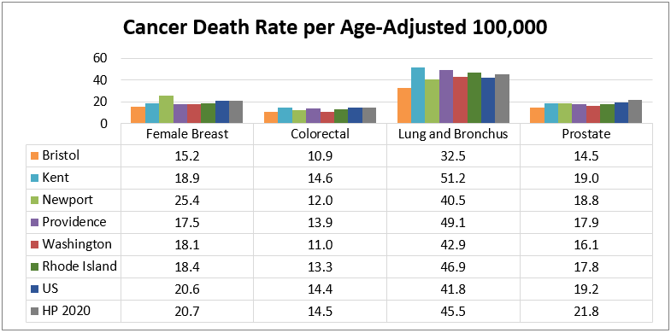
Source: Centers for Disease Control and Prevention, 2012–2016
Radon is the second leading cause of
lung cancer.

Rhode Island has higher reported incidence and death rates due to lung cancer than the nation. A potential contributor to higher rates is the prevalence of radon in homes across the state. Radon is a colorless and odorless gas produced from the decay of radium in rocks, soil, and water. It is the second leading cause of lung cancer. The Environmental Protection Agency recommends action to mitigate radon when testing shows radon levels of 4.0 pCi/L or higher. One in four homes in Rhode Island have radon levels at or above 4.0 pCi/L compared to the national average of 1 in 15 homes.
Radon levels of 1 in 4
Rhode Island homes exceed EPA standards; the national average is 1 in 15 homes

The Environmental Protection Agency distinguishes counties by radon zones. The following table shows each county’s radon zone, its average radon level, and the percentage of radon testing results above 4 pCi/L.
Average Reported Indoor Radon Levels
 | Radon Zone | Average Radon Level (pCi/L*) | Radon Testing Results Above 4 pCi/L
Bristol County | Zone 3 (less than 2 pCi/L) | 1.9 | 10.2%
Kent County | Zone 2 (2 to 4 pCi/L) | 3.3 | 23.8%
Newport County | Zone 2 (2 to 4 pCi/L) | 3.5 | 23.2%
Providence County | Zone 2 (2 to 4 pCi/L) | 2.4 | 14.4%
Washington County | Zone 1 (greater than 4 pCi/L) | 4.7 | 34.9%
Rhode Island | NA | 4.3 | NA
Source: Environmental Protection Agency, no date. *Picocuries per liter
Many forms of cancer, if identified early, can be successfully treated. Screening rates for three of the most common forms of cancer (cervical, breast, and prostate) are shown in the table below. Among Rhode Island females ages 21–65, more than 8 in 10 receive cervical cancer screenings. A similar percentage of females ages 50–74 receive breast cancer screenings. The prevalence of cervical and breast cancer screenings among females is higher in all Rhode Island counties compared to the nation. A higher percentage of Rhode Island males ages 40 or older receive prostate cancer screenings when compared to the nation, however, less than half of all males are screened.
Less than half of men age 40 or older are screened for prostate cancer

Adult Routine Cancer Screenings
(Green = Higher than the State or Nation; Red = Lower than the State or Nation)
 | Pap Test in Past Three Years  (Ages 21–65) | Mammogram in Past Two Years  (Ages 50–74) | PSA Test in Past Two Years (Ages 40+)
Bristol County | 91.3% | 96.5% | 40.7%
Kent County | 83.6% | 83.9% | 42.1%
Newport County | 82.3% | 85.1% | 48.6%
Providence County | 85.6% | 84.9% | 39.1%
Washington County | 94.7% | 86.1% | 47.6%
Rhode Island | 85.7% | 85.5% | 41.5%
United States | 79.8% | 77.6% | 39.5%
Source: Centers for Disease Control and Prevention, 2016; Rhode Island Department of Health, 2016

Chronic Lower Respiratory Disease
Chronic lower respiratory disease (CLRD) is the third most common cause of death in the nation. CLRD encompasses diseases like chronic obstructive pulmonary disorder (COPD), emphysema, and asthma, all of which contribute to lower quality of life and increased risk of early death.

CLRD Death Rates per Age-Adjusted 100,000 by Race and Ethnicity
(Green = Lower than the State or Nation; Red = Higher than the State or Nation)
 | Total Population | White,  Non-Hispanic | Black/African American,  Non-Hispanic | Latinx
Bristol County | 31.7 | 32.6 | NA | NA
Kent County | 42.8 | 44.0 | NA | NA
Newport County | 29.7 | 30.2 | NA | NA
Providence County | 35.2 | 39.1 | 20.3 | 9.4
Washington County | 30.7 | 31.0 | NA | NA
Rhode Island | 35.1 | 37.4 | 19.9 | 8.8
United States | 41.2 | 46.3 | 29.7 | 17.8
Source: Centers for Disease Control and Prevention, 2012–2016
*Data by race/ethnicity is limited due to low death counts.

CLRD Prevalence
(Green = Lower than the State or Nation; Red = Higher than the State or Nation)
 | Adults with Asthma (Current) | Children with Asthma (Ever) | Adults with COPD (Ever)
Bristol County | 9.8% | 6.0% | 3.9%
Kent County | 12.1% | 10.3% | 8.3%
Newport County | 11.9% | 15.5% | 7.4%
Providence County | 10.6% | 14.7% | 6.4%
Washington County | 12.0% | 16.9% | 8.0%
Rhode Island | 10.7% | 13.6% | 6.9%
United States | 9.3% | NA | 6.3%
Source: Centers for Disease Control and Prevention, 2016; Rhode Island Department of Health, 2016
Kent County has a higher CLRD death rate than the state and the nation and a higher rate of adult asthma
Rhode Island has a lower rate of CLRD death than the nation, however, a higher percentage of adults in the state are diagnosed with asthma and/or COPD. Kent County has a higher CLRD death rate than the state and the nation; the county has the highest percentage of adults with diagnosed with COPD or asthma.
Childhood asthma is more prevalent in Providence County than in the state
Asthma is the most common chronic condition among children. Between 2012 and 2016, asthma was the primary diagnosis for 7,917 emergency department visits among children under age 18. Black/African American and Latinx children had the highest rates of emergency department visits, as shown in the graph below. Children of all races and ethnicity residing in the four core cities had a higher rate of emergency department visits (12.2 per 1,000) compared to the rest of the state (4.5 per 1,000).

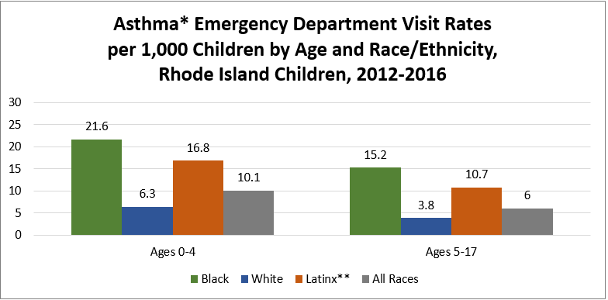
Source: Rhode Island Department of Health, 2012-2016
*Rates are for a primary diagnosis of asthma. **Latinx children can be of any race.

Diabetes
All Rhode Island counties have a lower prevalence of diabetes than the nation
Diabetes is among the top 10 causes of death in the nation. Diabetes can cause a number of serious complications. Type II diabetes, the most common form, is largely preventable through diet and exercise. The percentage of adults in Rhode Island diagnosed with diabetes is less than the nation, and decreased over the past three years. All Rhode Island counties have a lower prevalence of adult diabetes compared to the nation; however, the prevalence in both Kent and Providence counties exceeds the state.

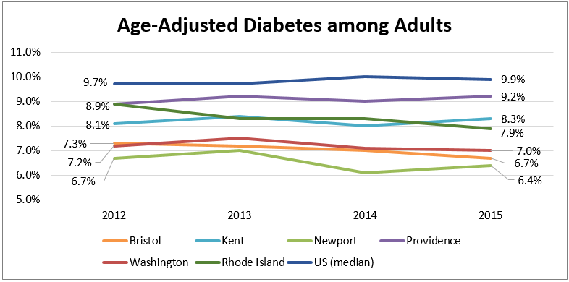
Source: Centers for Disease Control and Prevention, 2012–2015

The Rhode Island death rate due to diabetes is lower than the national death rate. All Rhode Island counties except Providence also have a lower death rate than the nation. Across the state, nation, and Providence County, the diabetes death rate is highest among Blacks/African Americans compared to Whites and Latinxs.

Diabetes Death Rate per Age-Adjusted 100,000
(Green = Lower than the State or Nation; Red = Higher than the State or Nation)
 | Total Population | White,  Non-Hispanic | Black/African American,  Non-Hispanic | Latinx
Bristol County | 17.0 | 16.7 | NA | NA
Kent County | 17.6 | 17.6 | NA | NA
Newport County | 11.5 | 11.4 | NA | NA
Providence County | 19.7 | 19.2 | 24.2 | 19.5
Washington County | 14.8 | 14.5 | NA | NA
Rhode Island | 17.8 | 17.4 | 24.0 | 18.1
United States | 21.1 | 18.6 | 38.6 | 25.6
Source: Centers for Disease Control and Prevention, 2012–2016
*Data by race/ethnicity is limited due to low death counts.
Senior Health

Chronic Disease Among Medicare Beneficiaries
Seniors face a growing number of challenges related to health and well-being as they age. People over 65 are more prone to chronic disease, social isolation, and disability. The following sections highlight key health indicators for the region’s senior population.

According to the CDC, “Among Medicare fee-for-service Beneficiaries, people with multiple chronic conditions account for 93% of total Medicare spending.”
Senior Medicare beneficiaries Kent and Providence counties experience more chronic disease than other counties.

The tables below note the percentage of Rhode Island Medicare beneficiaries who have been diagnosed with a chronic condition. Cells highlighted in red represent percentages that are higher than state and national benchmarks.

The presence of chronic conditions among Medicare beneficiaries varies by county. Medicare beneficiaries in Kent and Providence counties are more likely to have a chronic condition diagnosis.
Chronic Conditions Among Medicare Beneficiaries Age 65 Years or Older
(Red = Higher than the State or Nation)
 | Bristol County | Kent County | Newport County | Providence County | Washington County | Rhode Island | US
Alzheimer’s Disease | 12.4% | 12.0% | 11.2% | 12.4% | 9.3% | 11.7% | 11.3%
Arthritis | 30.5% | 33.0% | 29.3% | 31.2% | 32.9% | 31.5% | 31.3%
Asthma | 8.7% | 9.7% | 9.0% | 10.2% | 7.7% | 9.5% | 7.6%
Cancer | 10.6% | 10.8% | 10.8% | 10.2% | 10.2% | 10.4% | 8.9%
COPD | 9.3% | 12.4% | 11.3% | 12.1% | 10.6% | 11.7% | 11.2%
Depression | 16.2% | 18.5% | 16.9% | 18.5% | 14.5% | 17.5% | 14.1%
Diabetes | 23.7% | 27.0% | 22.3% | 29.3% | 21.6% | 26.6% | 26.8%
Heart Failure | 12.1% | 14.7% | 12.9% | 15.2% | 12.8% | 14.3% | 14.3%
High Cholesterol | 51.9% | 55.7% | 51.9% | 55.0% | 51.7% | 54.1% | 47.8%
Hypertension | 60.0% | 63.7% | 59.0% | 64.1% | 60.0% | 62.6% | 58.1%
Ischemic Heart Disease | 24.9% | 32.0% | 25.0% | 29.1% | 27.4% | 28.6% | 28.6%
Stroke | 3.9% | 4.3% | 5.7% | 4.3% | 3.9% | 4.4% | 4.2%
Source: Centers for Medicare & Medicaid Services, 2015

Number of Chronic Conditions among Medicare Beneficiaries Age 65 Years or Older
 | Bristol County | Kent County | Newport County | Providence County | Washington County | Rhode Island | US
0 to 1 condition | 29.9% | 25.9% | 31.1% | 26.8% | 30.5% | 27.9% | 32.3%
2 to 3 conditions | 33.2% | 31.3% | 32.1% | 30.8% | 33.3% | 31.6% | 30.0%
4 to 5 conditions | 22.0% | 24.2% | 21.2% | 23.5% | 21.9% | 23.0% | 21.6%
6 + conditions | 14.9% | 18.6% | 15.6% | 19.0% | 14.3% | 17.5% | 16.2%
Source: Centers for Medicare & Medicaid Services, 2015

Regular screenings are essential for the early detection and management of chronic conditions. The following table analyzes diabetes and mammogram screenings among Medicare enrollees. Rhode Island and all five counties exceed national metrics for both screenings. Medicare enrollees in Providence and Washington counties are more likely to receive annual hA1c tests for diabetes than the state. Medicare enrollees in Kent and Washington counties are more likely to receive mammograms than the state.

Chronic Disease Screenings among Medicare Enrollees
(Green = Higher than the State or Nation)
 | Annual hA1c Test from a Provider (65–75 Years) | Mammogram in Past Two Years (67–69 Years)
Bristol County | 89.0% | 76.0%
Kent County | 87.4% | 68.7%
Newport County | 87.0% | 67.8%
Providence County | 87.8% | 65.3%
Washington County | 88.0% | 72.6%
Rhode Island | 87.7% | 67.9%
United States | 85.0% | 63.0%
Source: Dartmouth Atlas of Healthcare, 2014

Alzheimer’s Disease
Alzheimer’s disease is currently the sixth leading cause of death in the United States. According to the National Institute on Aging, “Alzheimer’s disease is an irreversible, progressive brain disorder that slowly destroys memory and thinking skills, and, eventually, the ability to carry out the simplest tasks. In most people with Alzheimer’s, symptoms first appear in their mid-60s. Estimates vary, but experts suggest that more than 5.5 million Americans, most of them age 65 or older, may have dementia caused by Alzheimer’s.”
Providence County has a higher rate of death due to Alzheimer’s disease than the state and nation

In Rhode Island, only Providence County has a higher rate of death due to Alzheimer’s disease than the state and nation. Washington County and Kent County have a lower rate of death due to Alzheimer’s disease than the state and nation.

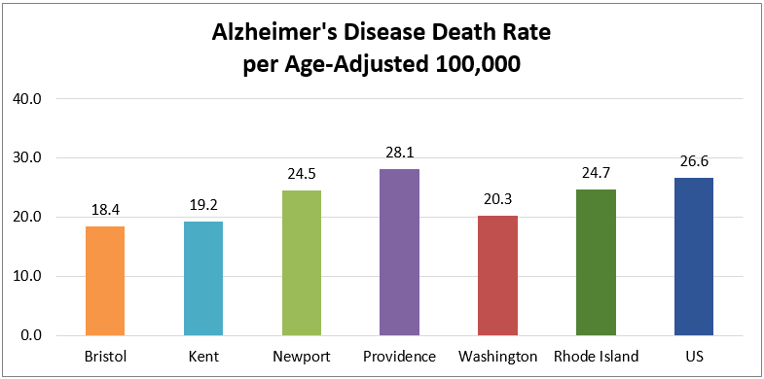
Source: Centers for Disease Control and Prevention, 2012–2016

Social Isolation Among Seniors
As seniors age, they are at risk for isolation due to physical limitations and decreasing social circles. One indicator of isolation is the percentage of seniors age 65 or olfer who live alone. In Rhode Island, seniors are more likely to live alone than seniors across the nation. Kent County has the highest percentage of seniors living alone compared to the state and other counties.
More Rhode Island seniors live alone; Kent County has the largest percentage in the state

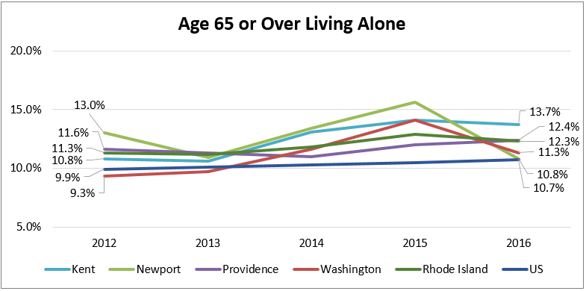
Source: US Census Bureau, 2012–2016
*Bristol County data is only available as a five-year aggregate based on data availability.

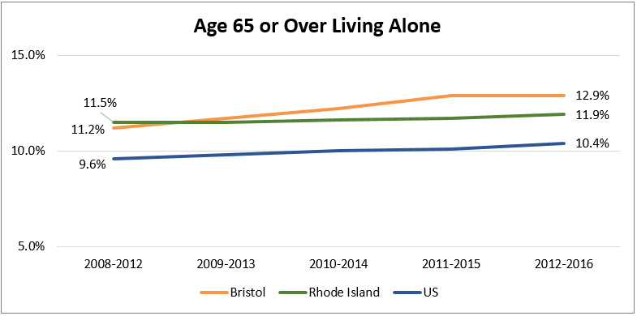
Source: US Census Bureau, 2008–2012 – 2012–2016
*The Bristol County uninsured rate is trended as a five-year aggregate based on data availability.

Behavioral Health
A higher percentage of Rhode Island adults have ever been diagnosed with a depressive disorder
Mental Health
A higher percentage of Rhode Island adults have been diagnosed with a depressive disorder when compared to the nation. Adults in Providence and Kent counties are among the most likely to have been diagnosed with a depressive disorder.

All Rhode Island counties except Bristol meet or nearly meet the Healthy People 2020 goal for suicide death. The suicide rate increased slightly in Providence County over the past six years, but declined in other counties.

Mental Health Measures
(Red = Higher than State or National Benchmarks)
 | Adults with a Depressive Disorder (Ever) | Suicide Rate per  Age-Adjusted 100,000 | Mental & Behavioral Disorders Death Rate per Age-Adjusted 100,000
Bristol County | 20.9% | 15.4 | 66.8
Kent County | 22.1% | 10.7 | 53.8
Newport County | 20.4% | 9.7 | 43.8
Providence County | 23.1% | 10.7 | 53.9
Washington County | 19.5% | 9.0 | 53.7
Rhode Island | 22.3% | 10.8 | 53.6
United States | 17.4% | 13.2 | 37.2
Healthy People 2020 | NA | 10.2 | NA
Source: Centers for Disease Control and Prevention, 2014–2016 & 2016; Healthy People 2020

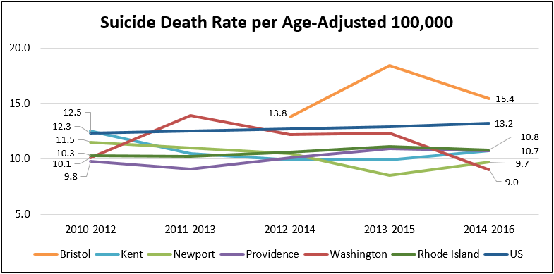Source: Centers for Disease Control and Prevention, 2010–2012 – 2014–2016
*Data for Bristol County are suppressed for years prior to 2012–2014 due to low death counts.

Mental and behavioral disorders span a wide range of disorders, including disorders due to psychoactive substance use, anxiety disorders, Schizophrenia and other delusional disorders, and mood or personality disorders. The disorders are not induced by alcohol and other psychoactive substances, but they may result from substance abuse. The mental and behavioral disorders death rate for all counties except Newport exceeds the state and national rate. The mental and behavioral disorders death rate increased by four or more points over the past six years in all counties, and 8.5 points in Providence County.

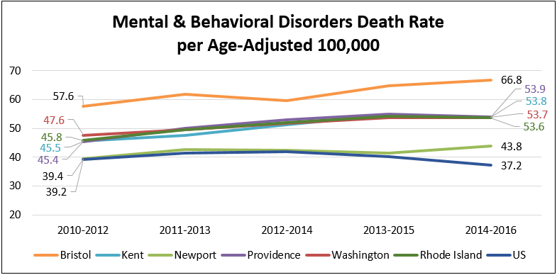
Source: Centers for Disease Control and Prevention, 2010-2012 – 2014-2016
*Death rates for Kent, Providence, and Washington counties and RI are color-coded to distinguish trends.
Substance Use Disorder
Excessive drinking and DUI deaths are higher for most counties than national averages
The category of substance use disorder includes alcohol and drug use, including the use of prescription drugs outside of the prescribed use.

Excessive drinking includes binge drinking and heavy drinking. Across Rhode Island, approximately 17% of adults report excessive drinking. The percentage of county adults who report excessive drinking is higher than the state and the nation for all counties except Providence.

Substance Use Disorder Measures
(Red = Higher than State or Nation)
 | Excessive Drinking (Adults) | Percent of Driving Deaths due to DUI | Drug-Induced Death Rate per  Age-Adjusted 100,000
Bristol County | 19.4% | NA | 24.9
Kent County | 19.9% | 43.1% | 28.9
Newport County | 23.8% | 44.0% | 18.5
Providence County | 17.8% | 34.5% | 30.1
Washington County | 21.4% | 50.0% | 26.1
Rhode Island | 17.4% | 39.1% | 28.0
United States | 18.0% | 29.0% | 17.9
Healthy People 2020 | NA | NA | 11.3
Source: Centers for Disease Control and Prevention, 2014–2016 & 2016; National Highway Traffic Safety Administration, 2012–2016; Healthy People 2020

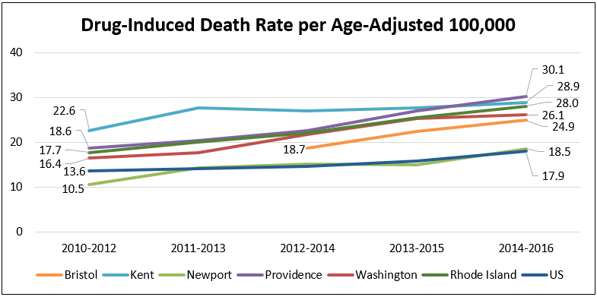
Source: Centers for Disease Control and Prevention, 2010–2012 – 2014–2016
*Data for Bristol County are suppressed for years prior to 2012–2014 due to low death counts.

Drug-induced deaths include all deaths for which drugs are the underlying cause of death, including drug overdoses and deaths from medical conditions resulting from chronic drug use.
The drug-induced death rate increased since 2010 across the state and all counties and exceeds national benchmarks

The drug-induced death rate increased across all counties over the past five years. The death rate for Rhode Island and all counties, except Newport, is more than double the Healthy People 2020 goal. The death rates for the state and for all counties exceed the national death rate.
In response to increasing overdose deaths across the state, Rhode Island implemented a data dashboard, PreventOverdoseRI.org, to track overdose deaths biannually. Per the website, “In 2014, over 240 Rhode Islanders lost their lives to overdose — that’s more than the number of people who died in car accidents, murders, and suicides combined.” In 2018, the number of overdose deaths increased to 314.

Overdose death data were analyzed as a five-year aggregate to illustrate more reliable counts and rates. The following map depicts overdose deaths per 100,000 population by city/town for 2014 to 2018.
Overdose Death Rate per 100,000 by Rhode Island City/Town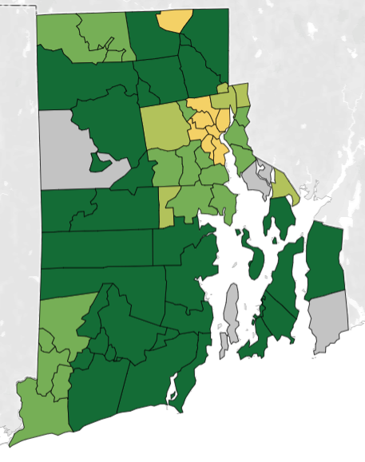
Source: Rhode Island Department of Health, 2014-2018

Overdose Death Rate per 100,000 Legend
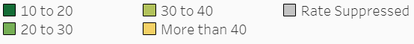
Overdose Death Rate per 100,000 for Rhode Island
Cities/Towns with Highest Death Rate, 2014-2018
 | Death Rate
Woonsocket | 48.6
Providence | 44.7
Central Falls | 37.2
West Warwick | 34.9
Pawtucket | 33.2
Johnston | 32.0
Warren | 32.0
Warwick | 27.1
North Providence | 26.2
East Providence | 25.5
Westerly | 24.6
Hopkinton | 22.0
Source: Rhode Island Department of Health, 2014-2018
Fentanyl-related overdoses are on the rise, accounting for >60% of deaths in 2017
Fentanyl is a significant contributing factor in death from overdose. With the rise in the presence of fentanyl in illicit drugs, there has been a commensurate rise in the number of overdose deaths from opiates.

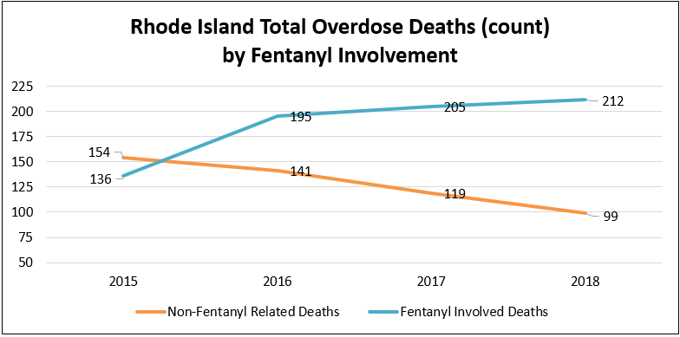
Source: Rhode Island Department of Health, 2015-2018
*From January to March 2019, there were 58 non-fentanyl related deaths and 13 fentanyl-involved deaths in Rhode Island.

Youth Behavioral Health
According to the Rhode Island Department of Health, 19% of statewide children ages 6 to 17 have a diagnosable mental health problem. At the time of the last CHNA, the Rhode Island Department of Health reported that in 2013, 2,737 youth were hospitalized across five hospitals with a primary diagnosis of mental disorder, an increase of 53% from 2003. The number of hospitalizations among children decreased from 2013 to 2016, but it is on the rise again, as shown in the graph below.
19% of Rhode Island youth ages 6–17 have a diagnosable mental health problem

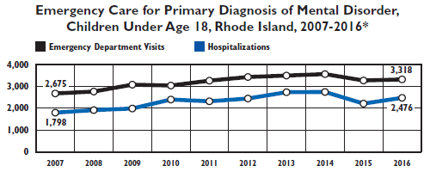
Source: Rhode Island Department of Health, 2007-2016
*Data reflect the number of visits or hospitalizations, not children. Children may have had more than one visit or hospitalization.
More than half of
Rhode Island youth
ages 3–17 who needed mental health services had trouble obtaining care

Child mental health services are often fragmented and/or unavailable in a timely manner. According to the Rhode Island Department of Health, in 2017, 55% of children ages 3 to 17 who needed mental health services had a problem obtaining care.

“In Federal Fiscal Year (FFY) 2017, 462 Rhode Island children and youth awaited psychiatric inpatient admission for an average of four days on medical floors at Hasbro Children’s Hospital. This is up from 212 children and three days in FFY 2016. Also during that time, an average of nine children per day were ready to leave the psychiatric hospital (up from the FFY 2016 average of six kids per day), but were unable due to a lack of step-down availability or there being no other safe placement (including at home).”

Bradley Hospital and Butler Hospital specialize in providing child psychiatric care. The following table shows the number of children under age 19 treated at either hospital by service type for FFY2017. The most common diagnoses among children treated in the inpatient setting were depressive disorders, anxiety disorders, adjustment disorders, bipolar disorders, and schizophrenia.

Children Under Age 19 Treated at Rhode Island Psychiatric Hospitals (FFY2017)
 | Bradley Hospital General Psychiatric Services |  | Bradley Hospital Developmental Disabilities Program* |  | Butler Hospital Adolescent Psychiatric Services
 | # Treated | Average Length of Stay | # Treated | Average Length of Stay | # Treated | Average Length of Stay
Inpatient | 791 | 21 days | 116 | 38 days | 509** | 8 days
Residential | 41 | 235 days | 34 | 238 days | NA | NA
Partial Hospitalization | 824 | 20 visits | 102 | 20 visits | 166 | 5 visits
Source: Rhode Island Department of Health, October 1, 2016–September 30, 2017
*The Bradley Hospital Developmental Disabilities Program offers specialized inpatient and residential services to children and adolescents who show signs of serious emotional and behavioral problems in addition to developmental disabilities.
**An additional 81 youth were treated in adult programs.
The percentage of high school students reporting an attempted suicide decreased since the 2016 CHNA from 14% to 11%
Young people who consistently feel depressed or sad may be at risk for self-harm and risky behaviors, including committing suicide. At the time of the last CHNA, the Department of Health reported that in 2013, 14% of Rhode Island high school students reported attempting suicide. In 2017, the percentage of students reporting an attempted suicide decreased to 11%. Between 2012 and 2016, 22 youth under the age of 20 died due to suicide.

Teen alcohol and drug use is both a symptom and a risk factor for increased injury, depression, and poor health. The following table depicts current substance use among Rhode Island high school students. The percentage of students reporting alcohol and marijuana use decreased from the 2016 CHNA. Students are less likely to use alcohol or misuse prescription drugs compared to the nation, but more likely to use marijuana.

Current Substance Use among Rhode Island High School Students
 | Alcohol Use | Marijuana Use | Prescription Drug Misuse
2013 Rhode Island | 26% | 34% | NA*
2017 Rhode Island | 23% | 23% | 4%
2017 United States | 30% | 20% | 14%
Source: Rhode Island Department of Health, 2013–2014 and 2017
*A change in methodology occurred between 2013 and 2017. A benchmark comparison is not reported.

Maternal and Child Health

Total Births and Teen Pregnancy
A total of 53,756 births occurred in Rhode Island between 2012 and 2016. Nearly 70% of births were to mothers residing in Providence County. Of the total births in Rhode Island, approximately 3,000 were to teen mothers between the ages of 15 and 19. The resulting teen birth rate of 15 per 1,000 is half the reported rate for the prior decade (30.4 per 1,000). However, the teen birth rate within the four core cities continues to exceed the remainder of the state.
The teen birth rate declined across Rhode Island, but continues to be higher in the core cities

Births in Rhode Island per 1,000 Females Ages 15–44, 2012-2016
 | Total Births |  | Non-Hispanic White Births |  | Non-Hispanic Black Births |  | Latinx Births
 | Count | Rate | Count | Rate | Count | Rate | Count | Rate
Bristol County | 1,690 | 36.8 | 1,535 | 34.0 | 21 | 144.8* | 59 | 68.2
Kent County | 7,853 | 53.5 | 6,830 | 46.5 | 124 | 43.9 | 466 | 69.3
Newport County | 3,416 | 45.3 | 2,676 | 38.0 | 179 | 51.5 | 389 | 98.5
Providence County | 36,351 | 53.6 | 17,219 | 36.2 | 3,910 | 59.2 | 11,625 | 81.2
Washington County | 4,277 | 35.2 | 3,741 | 32.2 | 70 | 37.1 | 178 | 40.0
Rhode Island | 53,756 | 50.1 | 32,143 | 37.6 | 4,309 | 57.9 | 12,729 | 80.0
Source: Rhode Island Department of Health, 2012–2016
*This rate is considered statistically unstable; please interpret with caution.

Teen Births (Ages 15–19) by County, 2012–2016
 | Birth Count | Birth Rate per 1,000
Bristol County | 45 | 4.5
Kent County | 303 | 12.5
Newport County | 112 | 8.2
Providence County | 2,361 | 19.3
Washington County | 159 | 5.5
Source: Rhode Island Department of Health, 2012–2016

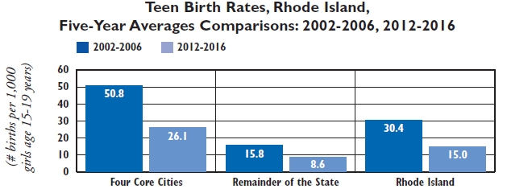
Source: Rhode Island Department of Health, 2002–2006 and 2012–2016
Maternal and Infant Health Outcomes
Engaging in prenatal care early in pregnancy increases the chances that a woman and her baby will have a healthy pregnancy and a healthy birth. Entry into prenatal care after the first trimester can suggest barriers to care such as lack of information, lack of access to health care or transportation, or behavioral health barriers. Rhode Island and all five counties meet the Healthy People 2020 goal of 77.9% of mothers accessing prenatal care in the first trimester. Women in Providence County experience the most barriers to accessing prenatal care, and have poorer birth outcomes compared to other counties.
All Rhode Island counties meet or nearly meet the HP 2020 goals for first trimester prenatal care, preterm birth, and low birth weight

Delayed prenatal care can contribute to low birth weight and preterm births. Low birth weight is defined as a birth weight of less than 5 pounds, 8 ounces, and is often a result of premature birth, fetal growth restrictions, or birth defects. Preterm birth is defined as birth before 37 weeks of pregnancy, and can contribute to infant death or disability. All Rhode Island counties meet the Healthy People 2020 goal for preterm births, and all counties except Providence meet the goal for low birth weight.

Breastfeeding is recommended to ensure healthy nutritional intake for babies and to promote bonding between mother and child. Washington County is the only county to meet the Healthy People 2020 goal for breastfeeding at the time of birth. Babies born to mothers residing in Providence County are the least likely to be breastfed.

Maternal and Child Health Indicators
(Green = Positive Finding Compared to State or National Benchmarks)
 | Delayed Prenatal Care | Preterm Births | Low Birth Weight | Breastfeeding
Bristol County | 12.4% | 7.5% | 5.7% | 79.5%
Kent County | 12.3% | 8.3% | 6.8% | 75.5%
Newport County | 11.6% | 8.7% | 6.8% | 73.2%
Providence County | 16.1% | 9.4% | 8.0% | 72.7%
Washington County | 8.5% | 7.5% | 6.2% | 83.7%
Rhode Island | 14.5% | 9.0% | 7.5% | 77.0%
White | 12.4% | 6.4% | 6.7% | NA
Hispanic | 17.4% | 8.1% | 8.2% | NA
Black | 21.9% | 9.2% | 11.3% | NA
Asian | 26.5% | 7.2% | 13.1% | NA
Native American | 15.6% | 8.9% | 10.3% | NA
Healthy People 2020 | 22.1% | 9.4% | 7.8% | 81.9%
Source: Rhode Island Department of Health, 2012–2016

Analyzing maternal and infant health outcomes by town helps to illuminate disparities that can reflect wider health and social disparities among populations. The following tables depict maternal and infant health outcomes for towns within the HARI member hospital home counties. Cells highlighted in yellow suggest areas for opportunity to improve health equity for these measures.

2012–2016 Providence County Infant Births by Maternal Characteristics and Town
 | Total Births | Births per 1,000 Girls 15–19 years | Delayed Prenatal Care | Breastfeeding at Time of Birth | Preterm Births | Low Birth Weight
Burrillville | 645 | 11.2 | 12.9% | 76% | 9.5% | 6.0%
Central Falls | 1,613 | 59.5 | 18.1% | 73% | 8.9% | 8.2%
Cranston | 3,927 | 10.1 | 13.1% | 79% | 9.5% | 7.6%
Cumberland | 1,661 | 5.8 | 10.6% | 82% | 7.1% | 5.9%
East Providence | 2,347 | 13.8^ | 13.2% | 76% | 8.1% | 6.6%
Foster | 166 | NA (n=5) | 11.4%^ | 89% | 9.0%^ | NA
Glocester | 337 | NA (n=11) | 11.9% | 80% | 10.1% | 5.6%^
Johnston | 1,330 | 11.9 | 11.3% | 75% | 7.8% | 7.1%
Lincoln | 977 | 6.9^ | 11.6% | 80% | 9.5% | 6.8%
North Providence | 1,625 | 17.6 | 13.2% | 75% | 9.8% | 8.3%
North Smithfield | 415 | NA (n=10) | 11.1% | 82% | 8.7% | 7.5%
Pawtucket | 4,885 | 26.1 | 18.1% | 74% | 10.0% | 9.0%
Providence | 12,511 | 21.6 | 18.8% | 73% | 10.0% | 8.8%
Scituate | 385 | NA (n=10) | 14.8% | 83% | 8.8% | 5.5%^
Smithfield | 641 | NA (n=10) | 9.7% | 82% | 4.8% | 3.9%
Woonsocket | 2,890 | 43.7 | 19.0% | 68% | 9.4% | 8.3%
Rhode Island | 53,752 | 15.0 | 14.5% | 77% | 9.0% | 7.5%
Source: Rhode Island Department of Health, 2012–2016
^The data are statistically unstable and rates or percentages should be interpreted with caution

2012–2016 Kent County Infant Births by Maternal Characteristics and Town
 | Total Births | Births per 1,000 Girls 15–19 years | Delayed Prenatal Care | Breastfeeding at Time of Birth | Preterm Births | Low Birth Weight
Coventry | 1,480 | 7.7 | 12.0% | 78% | 7.6% | 6.7%
East Greenwich | 576 | NA (n=9) | 10.8% | 86% | 9.4% | 8.0%
Warwick | 3,831 | 10.6 | 11.7% | 78% | 8.5% | 6.6%
West Greenwich | 223 | 10.8^ | 11.2% | 80% | 7.2%^ | 6.7%^
West Warwick | 1,741 | 26.6 | 14.6% | 70% | 8.0% | 6.8%
Rhode Island | 53,752 | 15.0 | 14.5% | 77% | 9.0% | 7.5%
Source: Rhode Island Department of Health, 2012–2016
^The data are statistically unstable and rates or percentages should be interpreted with caution

Neonatal Abstinence Syndrome
Babies exposed to opiates in the womb, who present with symptoms of withdrawal after birth, have often been labeled as having neonatal abstinence syndrome (NAS). Because the symptoms of NAS often occur after the baby has been discharged from the hospital and are often difficult to identify, the incidence of NAS is difficult to accurately capture. Additionally, a diagnosis of NAS can be stigmatizing to mother, baby, and family, creating a barrier to pregnant women reporting NAS or accessing recovery support for their child.

Neonatal Abstinence Syndrome
per 10,000 Delivery Hospitalizations
 | 2013 – 2018 NAS Rate
West Warwick | 120.3
Woonsocket | 161.9
Rhode Island | 96.1
Source: Rhode Island Department of Health, 2013-2018

Adverse Childhood Experiences
Adverse Childhood Experiences (ACEs) have significant negative impact on the mental, physical, and emotional development of children, and contribute to risky health behaviors, poor health outcomes, and premature death. The following tables profile the prevalence of ACEs in Rhode Island, including abuse, neglect, and family dysfunction (incarceration and domestic violence). Prevalence within the four core cities and the top 10 towns or cities for children experiencing ACEs are also shown.

Children of Incarcerated Parents
Children of incarcerated parents are more likely to experience educational challenges and physical and mental health difficulties. The rate of children of incarcerated parents within the four core cities in Rhode Island is nearly double the statewide rate. Woonsocket has the second highest rate overall with more than 250 children impacted.

Children of Incarcerated Parents: Top 10 Cities/Towns in Rhode Island
in Descending Order by Rate per 1,000 Children
 | Children of Incarcerated Parents per 1,000 Children*
West Warwick | 53.3
Woonsocket | 25.6
Providence | 23.6
Central Falls | 21.6
Pawtucket | 19.2
Newport | 18.6
North Providence | 14.7
Cranston | 9.9
Foster | 9.1
Burrillville | 8.4
Four Core Cities | 22.7
Rhode Island | 12.7
Source: Rhode Island Department of Health, September 30, 2017
*Data are self-reported by the incarcerated parent(s) and may include children over age 18.

Children Witnessing Domestic Violence
According to the 2018 Rhode Island Kids Count Factbook, “Children who are exposed to domestic violence are more likely to be victims of child abuse and neglect than those who are not.” In 2015, there were 5,553 domestic violence incidents resulting in arrests in Rhode Island, an increase from 2014 and 2013. Approximately 28% of the incidents in 2015 had a child present; 40% of these incidents originated in the four core cities.
Approximately 28% of domestic violence incidents resulting in arrest had a child present at the event

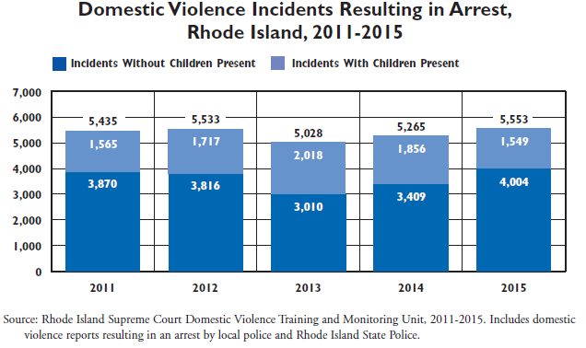

Domestic Violence Incidents Resulting in Arrests: Top 10 Cities/Towns in Rhode Island Shown in Descending Order by Number of Incidents With Children Present
 | Total Domestic Violence Incidents | Total Incidents with Children Present | Percent with Children Present
Providence | 942 | 290 | 31%
Pawtucket | 764 | 204 | 27%
Woonsocket* | 362 | 86 | 24%
Cranston | 357 | 86 | 24%
Warwick | 310 | 89 | 29%
East Providence | 271 | 83 | 31%
Westerly | 268 | 71 | 26%
New Shoreham | 207 | 61 | 29%
North Providence | 187 | 54 | 29%
Coventry | 125 | 45 | 36%
Four Core Cities | 2,215 | 621 | 28%
Rhode Island | 5,553 | 1,549 | 28%
Source: Rhode Island Department of Health, 2015 *Data for Woonsocket are provisional.

Child Abuse and Neglect
The Rhode Island Department of Health defines child abuse/neglect as the following:
- Child abuse includes physical, sexual, and emotional abuse.
- Child neglect includes emotional, educational, physical, and medical neglect, as well as a failure to provide for basic needs.
The rate of child abuse/neglect in the core cities is double the rate in the remainder of the state; Woonsocket has the highest rate
The Department of Health reported that, “In 2017 in Rhode Island, there were 2,404 indicated investigations of child abuse and neglect involving 3,357 children. The rate of child abuse and neglect per 1,000 children under age 18 was more than two times higher in the four core cities than in the remainder of the state. About half (52%) of the victims of child abuse and neglect in 2017 were young children under age six and one-third (34%) were ages three and younger.” Across the state, the rate of abuse and neglect among children is highest in the Core Cities, with Woonsocket the highest.

Indicated Investigations of Child Abuse and Neglect: Top 10 Cities/Towns
in Rhode Island in Descending Order by Rate per 1,000 Children
 | Indicated Investigations per 1,000 Children | Child Abuse/Neglect Victims per 1,000 Children
Woonsocket | 22.9 | 35.9
Central Falls | 18.4 | 30.8
Newport | 18.9 | 27.9
West Warwick | 15.1 | 25.9
Pawtucket | 17.2 | 24.1
Providence | 13.0 | 19.3
Hopkinton | 15.7 | 18.4
Westerly | 10.9 | 16.9
Bristol | 12.4 | 15.7
Warren | 9.8 | 13.9
Four Core Cities | 15.7 | 23.5
Remainder of State | 7.8 | 10.2
Rhode Island | 10.7 | 15.0
Source: Rhode Island Department of Health, 2017

Top 10 Cities/Towns in Rhode Island For Child Abuse and Neglect,
Shown in Descending Order by Rate of Victims per 1,000 Children
 | Total Indicated Investigations of Child Abuse/Neglect | Indicated Investigations per 1,000 Children | Total Victims of Child Abuse/Neglect | Child Abuse/Neglect Victims per 1,000 Children
Woonsocket | 226 | 22.9 | 355 | 35.9
Central Falls | 104 | 18.4 | 174 | 30.8
Newport | 77 | 18.9 | 114 | 27.9
West Warwick | 87 | 15.1 | 149 | 25.9
Pawtucket | 285 | 17.2 | 400 | 24.1
Providence | 540 | 13.0 | 805 | 19.3
Hopkinton | 29 | 15.7 | 34 | 18.4
Westerly | 52 | 10.9 | 81 | 16.9
Bristol | 45 | 12.4 | 57 | 15.7
Warren | 19 | 9.8 | 27 | 13.9
Four Core Cities | 1,155 | 15.7 | 1,734 | 23.5
Remainder of State | 1,170 | 7.8 | 1,526 | 10.2
Rhode Island | 2,404 | 10.7 | 3,357 | 15.0
Source: Rhode Island Department of Health, 2017

The following table shows the number of emergency department visits, hospitalizations, and deaths due to child abuse and/or neglect in Rhode Island. The number of emergency department visits due to child abuse/neglect declined from 2012 to 2016. The number of hospitalizations and deaths has been variable and accounted for 139 total hospitalizations and six child deaths from 2012 to 2016.

Rhode Island Emergency Department Visits, Hospitalizations, and Deaths
Due to Child Abuse and/or Neglect
 | # of Emergency Department Visits* | # of Hospitalizations* | # of Deaths**
2012 | 153 | 25 | 1
2013 | 133 | 34 | 3
2014 | 102 | 44 | 1
2015 | 92 | 28 | 0
2016 | 79 | 8 | 1
Total | 559 | 139 | 6
Source: Rhode Island Department of Health, 2012–2016. Data for 2015 and 2016 are provisional.
*The number of Emergency Department visits and the number of hospitalizations include both
suspected and confirmed assessments of child abuse and neglect.
**Due to a change in data source, data for child deaths due to child abuse and/or neglect are only
comparable with Factbooks since 2013.
Consistent with national trends, chlamydia and gonorrhea infection rates increased across all counties
Reportable Diseases
Sexually Transmitted Infections
The rate of infection of sexually transmitted infections (STIs) including chlamydia, gonorrhea, and HIV has been increasing across the nation and Rhode Island since 2010. As highly communicable conditions, STIs require reporting to the CDC and state and local health bureaus upon detection. The rate of chlamydia and gonorrhea infections in Rhode Island fall below national rates, but rates in Providence County exceed state and/or national benchmarks. Both STIs have increased across all counties between 2010 and 2016.
Chlamydia and gonorrhea infection rates in Providence County exceed state and/or national benchmarks
.
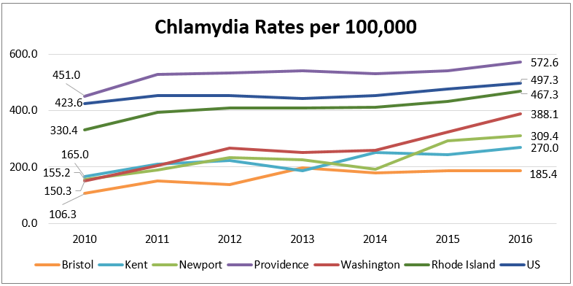
Source: Centers for Disease Control and Prevention, 2010–2016
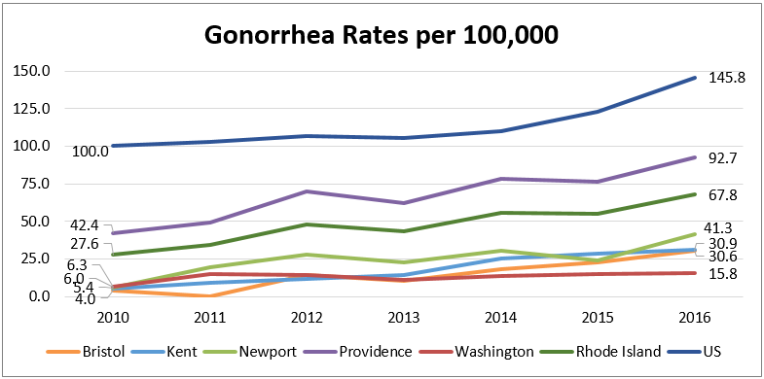
Source: Centers for Disease Control and Prevention, 2010–2016

The following table shows HIV prevalence for all five Rhode Island counties compared to the state and the nation. There are currently 2,357 people living with HIV in Rhode Island. Providence County is the only county with a higher HIV prevalence rate than the state and is similar to the national rate.

2015 HIV Prevalence
(Green = Lower than the State or Nation)
 | HIV Prevalence per 100,000 | HIV Cases
Bristol County | 88.5 | 38
Kent County | 100.2 | 143
Newport County | 148.7 | 108
Providence County | 346.1 | 1,863
Washington County | 63.6 | 71
Rhode Island | 259.5 | 2,357
United States | 362.3 | 971,524
Source: Centers for Disease Control and Prevention, 2015

Child Lead Screening and Poisoning
The CDC estimates that at least four million households with children are exposed to high levels of lead. Lead exposure increases the risk for central nervous system damage, slowed growth and development, and hearing and speech problems.
10% of children living in Core Cities and are screened for lead exposure have elevated blood lead levels

According to the Rhode Island Department of Health, 729 or 7% of statewide children eligible to enter kindergarten in fall 2019 who were screened for lead poisoning had elevated blood lead levels. The number of children with elevated blood lead levels has steadily declined in all areas of Rhode Island. However, the core cities of Central Falls, Pawtucket, Providence, and Woonsocket are disproportionately impacted, accounting for 433 of the 729 cases. Ten percent of children living in Core Cities and screened for lead exposure have elevated blood lead levels.

The following table depicts towns with a higher percentage of pre-kindergarten children with confirmed elevated blood lead levels compared to the state.

Lead Poisoning among Children Eligible to Enter Kindergarten in Fall 2019
 | Number Tested for Lead Poisoning | Confirmed Elevated Blood Lead Levels
 |  | Number | Percent
Providence | 2,573 | 292 | 11.3%
Central Falls | 300 | 32 | 10.7%
Pawtucket | 841 | 73 | 8.7%
East Providence | 469 | 40 | 8.5%
Warren | 106 | 9 | 8.5%
Rhode Island | 10,689 | 729 | 6.8%
Source: Rhode Island Department of Health, 2018

Lead paint was frequently used to paint the inside and outside of houses until 1978 when it was banned in the US due to its association with lead poisoning. As a result, homes built before 1978 are at risk of having lead paint inside, a leading exposure pathway for children. Housing stock in Rhode Island is older than the average age of US homes, with half of homes across the state being built before 1960. Providence County has the oldest housing stock with nearly 60% of homes built before 1960.

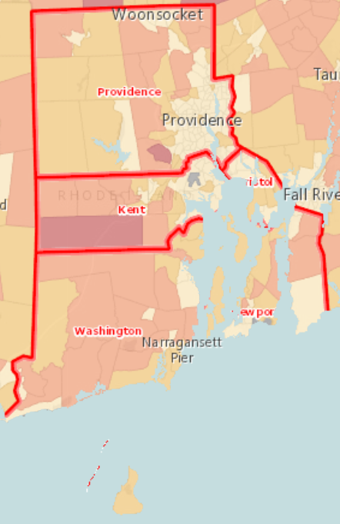 | Housing Units by Median Year Built and  Census Tract, US Census Bureau 2012–16  Newer than 1985  1976–1985  1966–1975  Older than 1966  No Data or Data Suppressed  Report Area

Key Informant Survey Results

Background
A Key Informant Survey was conducted with community stakeholders to solicit information about community health needs. A total of 45 individuals responded to the survey, including health and social service providers; community and public health experts; civic, religious, and social leaders; community planners; policy makers and elected officials; and others representing diverse populations including minority, low-income, and other underserved or vulnerable populations.

These “key informants” were asked a series of questions about their perceptions of community health including health drivers, barriers to care, community infrastructure, and recommendations for community health improvement.

Survey Participants
HARI and the CHNA hospitals solicited input from community partners across the state to participate in the survey. The table below shows the breakdown of participation by county. Many participants indicated that they served multiple counties. “Other” areas served as indicated by respondents included Bristol County in Massachusetts, the Blackstone Valley Region, and Pawtucket. A list of the represented community organizations and the key informants’ respective role/title is included in Appendix B. Key informant names are withheld for confidentiality.

Counties Served by Key Informants
 | Percent of Informants* | Number of Informants
Providence County | 77.8% | 35
Kent County | 57.8% | 26
Washington County | 51.1% | 23
Bristol County | 44.4% | 20
Newport County | 33.3% | 15
Other | 11.1% | 5
*Key informants were able to select multiple counties. Percentages do not add up to 100%.

Participants were asked to indicate if their organizations focused on any specific populations. About one-third of key informants indicated that they served all populations. As demonstrated in the table below, survey participants represent the interests of a broad mix of community stakeholders, including children and youth, families, low income/poor, racial and ethnic minorities, among other underserved populations. “Other” populations as indicated by respondents included domestic violence victims and survivors, individuals with substance use disorders, and individuals experiencing language and cultural barriers.

Populations Served by Key Informants
 | Percent of Informants* | Number of Informants
Children/Youth | 60.0% | 27
Families | 60.0% | 27
Low Income/Poor | 60.0% | 27
Women | 51.1% | 23
Latinx | 48.9% | 22
Seniors/Elderly | 46.7% | 21
Men | 44.4% | 20
Black/African American | 37.8% | 17
Immigrant/Refugee | 37.8% | 17
Uninsured/Underinsured | 37.8% | 17
Disabled | 35.6% | 16
Homeless | 35.6% | 16
Not Applicable (Serve All Populations) | 31.1% | 14
LGBTQ+ Community | 28.9% | 13
Asian/Pacific Islander | 22.2% | 10
American Indian/Alaska Native | 17.8% | 8
Other | 8.9% | 4
*Key informants were able to select multiple population groups. Percentages do not add up to 100%.

Health Perceptions
Choosing from a list of health issues, key informants were asked to rank order what they perceived as the top three health concerns impacting the population(s) they serve. An option for “other” was also provided. A following question asked participants to similarly rank order what they saw as the top three contributing factors to the health concerns they had indicated in the previous question. The top five responses for each question are depicted in the tables below. The tables are rank ordered by the number of informants that selected the issue within their top three choices.

More than one-third of informants saw mental health conditions as the No. 1 health concern in their community and 67% chose it among their top three community health concerns. Correlation between these data demonstrates more consensus around this issue than others on the list. More than 50% of informants selected substance abuse among their top three choices. Overweight/obesity and diabetes rounded out the top three health concerns with about 40% of informants’ selecting these issues.

Top Health Concerns Affecting Residents*
Rank | Health Concern | Informants Selecting  as the No. 1 Health Concern |  | Informants Selecting  Among Top 3 Health Concern
 |  | Percent | Count | Percent* | Count
1 | Mental health conditions | 37.2% | 16 | 67.4% | 29
2 | Substance abuse | 18.6% | 8 | 53.5% | 23
3 | Overweight/Obesity | 4.7% | 2 | 41.9% | 18
4 | Diabetes | 16.3% | 7 | 39.5% | 17
5 | Other** | 4.7% | 2 | 14.0% | 6
5 | Cancers | 0.0% | 0 | 14.0% | 6
5 | Heart disease and stroke | 0.0% | 0 | 14.0% | 6
*Key informants were able to select multiple health concerns. Percentages do not add up to 100%.
**Other responses: lead exposure, and affordable, healthy housing.

More than half (54.5%) of key informants saw poverty among the top three contributing factors to health concerns, with 25% selecting it as a the No. 1 contributor. There was less consensus among informants regarding other factors that most contribute to community health concerns. Health habits and ability to afford healthcare received the next highest votes after poverty.

Top Contributing Factors to Community Health Concerns
Rank | Contributing Factor | Informants Selecting as the No. 1 Contributor |  | Informants Selecting  Among Top 3 Contributor
 |  | Percent | Count | Percent* | Count
1 | Poverty | 25.0% | 11 | 54.5% | 24
2 | Health habits (diet, physical activity) | 11.4% | 5 | 29.5% | 13
3 | Ability to afford healthcare (doctor visits, prescriptions, deductibles, etc.) | 13.6% | 6 | 27.3% | 12
4 | Drug/Alcohol use | 2.3% | 1 | 22.7% | 10
5 | Stress (work, family, school, etc.) | 6.8% | 3 | 18.2% | 8
5 | Other** | 4.5% | 2 | 18.2% | 8
5 | Lack of preventive healthcare (screenings, annual check-ups) | 2.2% | 1 | 18.2% | 8
*Key informants were able to select multiple contributing factors. Percentages do not add up to 100%.
**Other responses: Social determinants of health, sedentary lifestyles, too much screen time, racism, sexism, mental health outpatient services for children and adolescents not requiring home-based services, and inadequate Medicaid funding for care.

Key Informant Comments
Informants’ were invited to provide freeform comments to expand upon their quantitative responses to the previous questions. Verbatim comments are included below.
- “…Planning efforts involving all stakeholders and communities should be strengthened to decrease duplication of effort, increase efficiencies across the state, maximize use of funding, and centralize systems of care. The current system is fragmented and confusing to patients, clients, community stakeholders, and providers.”
- “Progress is being made in some of these areas through the local Health Equity Zone (HEZ) and the work of many partners to increase access to healthy foods, exercise, asthma, recreation, etc.”
- “There is a large disparity between those who can and cannot afford healthcare. Those with Medicaid have increased barriers. However, more and more individuals who have private insurance are also finding it difficult to manage their health due to high premiums, deductibles, and co-pays. People are having to choose between paying rent, buying food, and costs associated with managing their healthcare.”
- “There is a dearth of community based care for mental health and substance abuse.” [in Washington County]
- “We need a greater focus on “health” over “healthcare.” Specifically, being holistic and addressing trauma in our communities. Health equity and addressing social determinants of health require us to seek solutions across sectors with community engagement and direct investment in elements of social determinants of health.”
- “Children do not spend enough time with unstructured play outdoors. Most residents do not spend enough time outdoors in nature even though there are many places where they can do this. Stress permeates our culture and people do not learn strategies for managing stress and balancing their lives.”
- “In the nursing home community, the individuals we care for typically suffer from dementia or other age-related disability. Depression is also a chronic problem, because these individuals have experienced so much loss; the majority of them have outlived their spouse and/or friends. They have lost their independence, their good vision and hearing, their health, etc. It's a very challenging time of life, whether they receive care at home, in assisted living, or in a nursing facility. The state has sufficient nursing facility beds, but those facilities are financially starved due to Medicaid funding shortfalls. This means patients must be in semi-private rooms, and staff are too busy to provide the relaxed and friendly care they deserve. They receive good primary care, but there are SERIOUS shortfalls in dental and behavioral healthcare for nursing home residents.”
- “Washington County has pockets of poverty that are overshadowed by high income areas.”
- “There aren't enough providers because the reimbursement rates are so low and [rates] don't take into account the social factors contributing to missed appointments, etc.”
- “Families are facing multiple stressors. Availability of providers, the ability to pay, availability of alcohol and drugs, lack of adequate housing and transportation, limited educational level, low community connectivity, low understanding of effects of school truancy/absenteeism/academic failure on a child's future, long history of trauma in our communities.”
- [In Washington County], “We have lost services in the last 10 years. We no longer have a true community mental health agency, but an off-shoot of Lifespan that has NO out-patient clinical services in place for children and adolescents other than in-home services which are needed by very few children. The insurance companies do not provide adequate reimbursement to providers, so many do not take insurance. The State of Rhode Island joined our community mental health services with Kent County and we no longer have a fulltime child and adolescent psychiatrist available. Ten years ago we had a full [complement] of children's services, including a partial hospital program. Now we overload the emergency rooms with patients....[they are] sent home with NO services and the problems continue!”
- “The social and environmental determinants of health are the ground in which all of the health concerns occur. Hospitals should devote significant investment in the communities that are most affected by these determinants. Simply providing care when there are problems misses the point. The hospitals should support strategies, such as the Health Equity Zones, that are doing work in the community where 80-90% of health occurs. Healthcare is obviously critically important, but prevention is actually where we need to focus more of our resources. That is where we are going to address asthma, obesity, mental health concerns, diabetes, and other illnesses that are exacerbated and disproportionately affected by lack of employment, poor housing, etc., and fed by systemic racism.”
- “The lack of specific ethnic data in certain categories, which may contribute to inaccurate generalization about health issues affect among Southeast Asians (SEA) in this state. A combination of cultural factors, including the violence and trauma-laden refugee experience following the Vietnam War, contributes to a higher risk of chronic illnesses and associated risk factors among SEA. A lack of ethnic-specific data collection and reporting on SEAs in Rhode Island makes it difficult to provide a clear snapshot of the health status of the SEA community. Areas such as mental health lack SEA specific data although the SEA refugee population has been historically afflicted with trauma and violence. However, data collected nationally and in other states show that the SEA community is disproportionately affected by cancer and hepatitis B and faces unique risks in term of heart disease. The majority of SEA health issues are associated with various barriers to healthcare access; low rates of preventative care to detect, monitor, and treat chronic and infectious diseases; and generally poor knowledge of important health issues.”
- “Our community (East Bay) is very diverse economically and that makes it difficult to say that the region is served in any one way. Economics is the No.1 factor when it comes to the ability to meet the challenges of health concerns. That is not necessarily the same as poverty—it is the crunch of the working poor and lower level middle class. These families face increased stress that is a result of their economic situation that impacts food choices (e.g. fast food versus fresh food) that are not related to education or availability.”

Healthcare Access
Key informants were asked to rate their agreement to statements pertaining to access to care using a scale of (1) “strongly disagree” to (5) “strongly agree.”

Access to Healthcare Statements in Descending Order by Mean Score
 | Strongly Disagree | Disagree | Neither agree nor disagree | Agree | Strongly Agree | Mean Score
 | (1) | (2) | (3) | (4) | (5)
Residents have a regular primary care provider/doctor/practitioner that they go to for healthcare. | 2.2% | 20.0% | 37.8% | 33.3% | 6.7% | 3.22
Providers in the community are culturally sensitive to race, ethnicity, cultural preferences, etc. of patients. | 2.2% | 35.6% | 33.3% | 22.2% | 6.7% | 2.96
There are a sufficient number of providers that accept Medicaid/ Medical Assistance in the community. | 11.1% | 35.6% | 35.6% | 17.8% | 0.0% | 2.60
Residents have available transportation (public, personal, or other service) for medical appointments and other services. | 8.9% | 53.3% | 22.2% | 11.1% | 4.4% | 2.49
Residents have access to a consistent source of affordable healthy foods. | 11.1% | 57.8% | 13.3% | 13.3% | 4.4% | 2.42
There are a sufficient number of bilingual providers in the community. | 15.6% | 57.8% | 20.0% | 6.7% | 0.0% | 2.18

Access to adequate and timely health services is a key contributor to the health of a community. As shown in the table above, key informants were divided on a number of issues affecting residents’ access to care. Key informants were most affirmative with regard to residents’ access to a regular primary care provider. Survey respondents were most divided on the cultural sensitivity of providers with 38% disagreeing, 33% neutral, and 29% agreeing to the statement.

Key informants mostly disagreed or were neutral with regard to the number of Medicaid providers available in their communities. Only 18% “agreed” or “strongly agreed” that there were a sufficient number of providers that accept Medicaid. Most informants disagreed that residents had access {transportation (62%); healthy foods (69%) and bilingual providers (73%)}.

Provider Availability
Key informants were asked to rate their agreement to statements pertaining to the availability and accessibility of primary and specialty care providers using a scale of (1) “strongly disagree” to (5) “strongly agree.”

Healthcare Provider Availability and Accessibility
 | Strongly Disagree | Disagree | Neither agree nor disagree | Agree | Strongly Agree | Mean Score
Primary Care Services
Residents receive care when they need it. | 4.5% | 27.3% | 29.5% | 31.8% | 6.8% | 3.09
There are a sufficient number of providers in the community. | 14.0% | 39.5% | 11.6% | 27.9% | 7.0% | 2.74
Specialty Care Services
Residents receive care when they need it. | 11.4% | 38.6% | 31.8% | 18.2% | 0.0% | 2.57
There are a sufficient number of providers in the community. | 20.9% | 20.9% | 27.9% | 25.6% | 4.7% | 2.72
Dental Care Services
Residents receive care when they need it. | 11.4% | 43.2% | 27.3% | 18.2% | 0.0% | 2.52
There are a sufficient number of providers in the community. | 23.3% | 20.9% | 23.3% | 30.2% | 2.3% | 2.67
Vision Care Services
Residents receive care when they need it. | 7.0% | 30.2% | 39.5% | 23.3% | 0.0% | 2.79
There are a sufficient number of providers in the community. | 4.8% | 23.8% | 40.5% | 26.2% | 4.8% | 3.02
Mental Healthcare Services
Residents receive care when they need it. | 34.1% | 38.6% | 13.6% | 13.6% | 0.0% | 2.07
There are a sufficient number of providers in the community. | 34.9% | 34.9% | 18.6% | 11.6% | 0.0% | 2.07
Substance Abuse Services
Residents receive care when they need it. | 20.5% | 50.0% | 11.4% | 13.6% | 4.5% | 2.32
There are a sufficient number of providers in the community. | 30.2% | 39.5% | 16.3% | 11.6% | 2.3% | 2.16

Key informants were neutral or divided on many of the measures related to availability and accessibility of healthcare services. Most key informants took a neutral position on whether resident received care when they need, but the majority disagreed that there were sufficient number of primary care providers in the community. With regard to specialty care, informants mostly disagreed that residents receive care when they need it, and mostly disagreed or were neutral that there were sufficient specialty providers in the community.

Key informants felt that residents do not receive dental care when they need it, and generally disagreed or were neutral as to sufficient providers available. Responses were similar with regard to vision care, with most informants indicating that residents do not receive care when they need it, while indicating neutral opinions on the availability of providers.
70% of key informants thought residents did not receive behavioral health services when they need it, and that there are not enough providers

The strongest consensus was with regard to mental healthcare and substance abuse services. Approximately 70% of informants “disagreed” or “strongly disagreed” that residents receive mental healthcare or substance abuse care when they need it and that there was not a sufficient number of these providers in the community.

Choosing from a list of specified reasons, key informants were asked to rank order what they perceived as the top three reasons that individuals who have health insurance do not receive regular care. An option for “other” was also provided. The top five responses are depicted in the table below and rank ordered by the number of informants that selected the reason among their top three choices.

Top Reasons Individuals with Health Insurance Do Not Receive Regular Care
Rank | Reason | Informants Selecting  as the No. 1 Reason |  | Informants Selecting Among Top 3 Reasons
 |  | Percent | Count | Percent* | Count
1 | Unable to afford care (copays, deductibles, prescriptions, etc.) | 36.6% | 15 | 61.0% | 25
2 | Challenges of navigating the healthcare system | 12.2% | 5 | 43.9% | 18
3 | Lack of transportation to access healthcare services | 12.2% | 5 | 34.1% | 14
4 | Awareness/Emphasis of preventive health measures | 7.3% | 3 | 29.3% | 12
5 | Providers not accepting insurance/new patients | 4.9% | 2 | 29.3% | 12
*Key informants were able to select multiple reasons. Percentages do not add up to 100%.

“Unable to afford care” was selected as the No. 1 reason that insured individuals do not receive regular care with 37% selecting it as the No. 1 reason and 61% of respondents selecting it within their top three reasons. Higher consensus among this issue suggests that cost of care, not insurance access, is a larger barrier for residents to receive care.

“Challenges of navigating the healthcare system” was ranked second, above lack of transportation, awareness of preventive health measures, and providers accepting insurance or new patients. This ordering suggests that improving ease of accessing care could increase the frequency that residents access preventive care.

Social Determinants of Health
Healthy People 2020 defines social determinants of health as conditions in the environments in which people are born, live, learn, work, play, worship, and age that affect a wide range of health, function, and quality of life outcomes and risks. Informants were asked to rate social determinants of health across five different dimensions: economic stability; education; health and healthcare; neighborhood and built environment; and social and community context using a scale of (1) “very poor” to (5) “excellent.”

The mean scores for each dimension are listed in the table below in rank order, followed by a graph showing the scoring frequency. Mean scores fell between 2.20 for “economic stability” and 2.90 for “health and healthcare,” with most respondents rating the listed social determinants as “poor” or “average.” Health and healthcare received the highest frequency of “good” scoring.

Social Determinants of Health Rating in Descending Order by Mean Score
Ranking | Social Determinant of Health | Mean Score
1 | Health and Healthcare | 2.90
2 | Education | 2.54
3 | Social and Community Context | 2.49
4 | Neighborhood and Built Environment | 2.32
5 | Economic Stability | 2.20

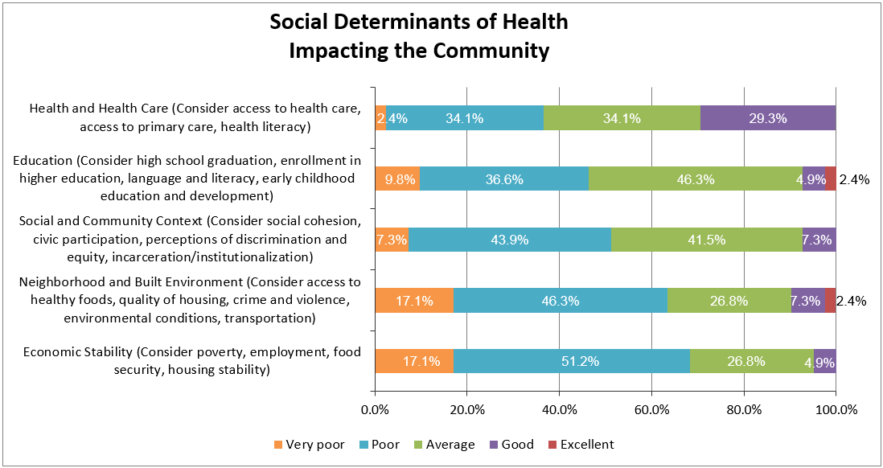
Survey participants were asked to provided insight into their scoring of the social determinants of health dimensions using a freeform response. Verbatim comments are listed below. As demonstrated by the comments, many key informants acknowledged a strong link between socioeconomic factors and health status.
- “Overall, Washington County looks good on most measures, except mental health where we stand out, i.e. suicide, binge drinking, motor vehicle accidents caused by impaired drinking, etc. Health disparities occur in small poverty pockets under the radar. Lack of transportation and social isolation in our rural suburban landscape affect residents' ability to have access to medical care, healthy foods, exercise, etc.”
- “Even though there may be access to healthcare, fresh foods, and services in a given community, whether a family can take advantage of those depends on their unique situation. In some ways, families who have economic instability who live in places where there are lots of options are just as challenged as families who live in areas with no options.”
- “Our organization has seen an increase in homelessness, food insecurity, and lack of transportation. Mental health challenges impact ability to work and manage day to day life.”
- “My community suffers from a lack of available mental healthcare at all income levels; lack of transportation for low income residents; pockets of deep poverty hidden in a generally well off community; and a cultural acceptance of unhealthy eating habits and overweight. School meals are of a particular concern. They follow RIDE "guidelines" but in practice offer children a lot of prepackaged foods that look like less healthy products for sale in grocery stores. Companies are advertising unhealthy foods to children and families through school meals. The look alike products available in the grocery stores are high in sugar, sodium, and unhealthy fats and low in whole grains. They do not teach children and families about healthy eating habits.”
- “Isolation is the number one cause of depression in the elderly. Without access to transportation, social engagement, and in-home care, we will see a higher use of ER and hospital visits in part because of their depression and loneliness.”
- “Addressing SDOH requires both a collective impact approach and hospitals as anchors leveraging their resources to engage in economic security, direct housing investments, and trauma-informed community development.”

Community Resources
Key informants were asked what resources are missing in the community that could help residents optimize their health. Respondents could choose as many options as they thought applied. Nearly 75% of informants chose “mental health services and transportation options as the top missing resources within the community. Approximately 68% included multi-cultural or bilingual healthcare providers and 65% checked substance abuse services. Sixty percent of informants selected healthy food options as a missing resource within the community. Just over half of the informants indicated a need for housing or additional health and wellness education.

Top 10 Missing Resources within the Community to Optimize Health
Ranking | Resource | Percent of Informants | Number of Informants
1 | Mental health services | 72.5% | 29
1 | Transportation options | 72.5% | 29
3 | Multi-cultural or bilingual healthcare providers | 67.5% | 27
4 | Substance abuse services | 65.0% | 26
5 | Healthy food options | 60.0% | 24
6 | Health and wellness education and programs | 52.5% | 21
6 | Housing | 52.5% | 21
8 | Outlets for physical activity (parks, rec centers, gyms, walking trails, etc.) | 40.0% | 16
9 | Child care providers | 35.0% | 14
9 | Dental care | 35.0% | 14

Specific comments from key informants related to missing resources in the community are included below. Transportation, housing, heath equity, cultural competency, and promotion of community health workers and other evidence-based programs are discussed.
- “What are the barriers that keep people from spending more time in parks and other outdoor places? Perhaps it is knowledge that these places are there. Perhaps it is the lack of time. Perhaps there needs to be more organized groups that people can join for walking?”
- “Resources present in the community should not be considered available/adequate unless they are affordable to the lowest-income residents and can be accessed without fear due to immigration status (or other similar factors).”
- “Spanish is NOT the only bi-lingual challenge. And, with language comes cultural norms that are often not appreciated or respected by providers. One cannot trust a provider who makes the patient feel stupid or 'less than' because of lack of knowledge or exposure to the American system and way of life.”
- “Bring more community health workers as key members of the health team, establishing the connections between community and clinic. Invest in evidence-based healthy life style programs available in the communities where the patients live.”
- “In many areas of the state, transportation is the key factor. Most places do not have consistent transportation options. Hours of operation for healthcare is also challenging some times.”
- “Affordable housing is a problem across the state and pressures are especially high in Washington County with economic pressures for student and tourist housing. Transportation is a significant issue with minimal public transportation available. Although the minority/multi-cultural/non-English speaking population is small, services for them are fairly nonexistent. Mental health services are hard to navigate and the full continuum of mental healthcare is not available in Washington County, i.e. no intensive outpatient programs, crisis care, etc. Families with children with behavioral health challenges have few supports available to them.”

When asked how local and regional healthcare providers can better engage community members to achieve optimal health outcomes, respondents made recommendations for community collaboration; increased focus on prevention; and improved healthcare access. Specific recommendations from informants included:

- Advocate for healthy meals, increased physical activity, and improved health education for students
- Collaborate with and invest in the local Health Equity Zones
- Employ community health workers to assist and support patients
- Encourage coordination of care among providers
- Engage with community non-profits to maximize efforts and collaboration
- Improve healthcare access (evening hours with childcare provided, specialty care providers)
- Partner with local community development and housing agencies
- Promote cultural sensitivity by employing a multi-racial/multi-cultural staff
- Provide prevention and wellness programs for community members

Evaluation of Community Health Impact from 2016 CHNA Implementation Plan for Community Health Improvement

In response to the 2016 CHNA, CharterCARE developed an Implementation Plan to address community health needs in the communities served by Our Lady of Fatima Hospital and Roger Williams Medical Center. Systemwide goals and objectives were created and initiatives carried out in accordance with the Implementation Plan.

As part of its 2013-16 Community Health Implementation Plan, CharterCARE provided community benefit activities, including community health education, health care support services, social and environmental improvement activities, and community contributions. To provide ongoing oversight and expertise, CharterCARE created an interdisciplinary staff and physician Community Health Needs Planning and Implementation Plan (CHNPIT) to oversee development and implementation of all community health outreach efforts. Goals and specific strategies that CharterCARE engaged in during the 2013-16 reporting cycle are outlined below.

Asthma:
- Hosted an annual asthma information night free and open to the public, featuring education and awareness regarding risks, detection, and treatment of asthma.
- Identified ways in which CharterCARE can collaborate with American Lung Association to enhance and extend the organization’s asthma awareness efforts.

Breast Cancer Incidence:
- Hosted free, public bi-annual breast health information nights
- Hosted quarterly breast care screening clinics free of charge and open to residents of the service area communities. Mammograms (free for the uninsured) will be offered and referral to the Breast Health Program will be made to those who are diagnosed as needing follow up care.

Diabetes:
- Conducted public outreach efforts to educate residents about the risk factors for diabetes.
- Enhanced care coordination and diabetes self-management in physician practices.
- Hosted quarterly diabetes screening clinics free of charge and open to residents of the service area communities. Pamphlets describing diabetes causes, warning signs and treatment options will be distributed. Referral to the Fatima Diabetes Management Center will be made for those who test positive for the disease.
- Improved prevention behaviors (e.g., participation in physical activity and healthy eating) in persons with pre-diabetes who are at high risk for diabetes.
- Used the physician referral service to direct the public to the diabetes education program.

Health Care Access:
- Produced a directory of community health care services and made available to the public through the hospitals’ websites.

Mental Health & Substance Abuse:
- Hosted bi-annual mental health and substance abuse information nights free and open to the public, featuring presentations by physicians and other clinical treatment and assessment professionals.
- Produced collateral material and public service announcements to increase awareness of mental health issues.

Overweight & Obesity:
- Developed a promotional campaign educating target audiences and caregivers about high risk behaviors as well as available resources and strategies to reduce risk factors.
- Hosted quarterly weight loss seminars free-of-charge and open to residents of the service area communities. Dieticians, nutritionists and weight loss surgery personnel provided presentations.

Tobacco Use:
- Hosted a smoking cessation program free of charge and open to residents of the service area communities.
- Conducted tobacco use outreach to public and private high schools in the service area via school-based education and awareness events.

Access to Health Service Outreach in Pawtucket Rhode Island
In response to the sudden closing of Memorial Hospital, CharterCARE conducted an extensive outreach campaign to the public and to Pawtucket-based physician practices designed to educate the area about alternatives for access to health services. This included newspaper advertising, digital advertising, flyers as well as a public health fairs
:

Prioritization Process and Identified Priority Areas

To work toward health equity, it is imperative to prioritize resources and activities toward the most pressing health and crosscutting needs within communities. In determining the issues on which to focus efforts over the next three-year cycle, CharterCARE solicited input from community partners and stakeholders and sought to align efforts with existing initiatives headed by the Rhode Island Department of Health, the HEZs, and other community partnerships.

Qualitative feedback was considered in conjunction with statistical health data to identify trends and the impact of social determinants of health to determine priority needs on which to focus during the 2019-2022 reporting cycle.

The CHNA findings confirmed that many residents within the CharterCARE service area experience greater socioeconomic disparities and increased health needs than in other parts of the state. Cyclical poverty, exposure to violence, and higher disease incidence lead to shortened life expectancy for many residents.

For many years, CharterCARE has strategically invested in health services and community health improvement initiatives to reduce health disparities and increase equitable access to services across our service area. Our ongoing initiatives to improve access to and delivery of behavioral health services to people across Rhode Island demonstrates our understanding of the most pressing needs of the communities we serve, and our commitment to meet those needs.

In line with our community health improvement initiatives, CharterCARE will continue to focus on advancing treatment and prevention of mental health and substance use disorders; expanding access to care to reduce health disparities related to chronic disease; and improving the well-being of mothers, infants, and children.

Community Health Priorities for 2019-2022 Implementation Plan

Behavioral Health: advance the treatment of mental health and substance use disorders
Chronic Disease: expand access to care to reduce health disparities for chronic diseases
Maternal and Child Health: improve the well-being of mothers, infants, and children

Board Approval
The CharterCARE board of directors reviewed and approved the 2019 CHNA Final Report in March 2020. The report is available for review and comment on the CharterCARE website at http://www.chartercare.org/about-chartercare/community-health-needs-assessment.

Appendix A: Public Health Secondary Data References

Centers for Disease Control and Prevention. (n.d.). Atlas Plus. Retrieved from
https://gis.cdc.gov/grasp/nchhstpatlas/charts.html
Centers for Disease Control and Prevention. (2017). BRFSS prevalence & trends data.
Retrieved from http://www.cdc.gov/brfss/brfssprevalence/index.html
Centers for Disease Control and Prevention. (2018). CDC wonder. Retrieved from
http://wonder.cdc.gov/
Centers for Disease Control and Prevention. (2018). Diabetes data and statistics. Retrieved
from https://www.cdc.gov/diabetes/data/
Centers for Disease Control and Prevention. (2017). National program of cancer registries
(NPCR). Retrieved from https://www.statecancerprofiles.cancer.gov/incidencerates/
Centers for Disease Control and Prevention. (2018). YRBSS results. Retrieved from
https://www.cdc.gov/healthyyouth/data/yrbs/results.htm
Centers for Medicare & Medicaid Services. (2017). Chronic conditions. Retrieved from
https://www.cms.gov/Research-Statistics-Data-and-Systems/Statistics-Trends-and-
Reports/Chronic-Conditions/CC_Main.html
Centers for Medicare & Medicaid Services. (2018). National provider identification file. Retrieved
from http://www.countyhealthrankings.org/
County Health Rankings & Roadmaps. (2018). Rhode Island. Retrieved from
http://www.countyhealthrankings.org/
Dartmouth Atlas of Health Care. (n.d.). Diabetes monitoring & mammography screening.
Retrieved from http://www.countyhealthrankings.org/
Dignity Health/Truven Health Analytics. (2018). Community need index. Retrieved from
http://cni.chw-interactive.org/
Environmental Protection Agency. (n.d.). Radon. Retrieved from
https://www.epa.gov/radon/epa-map-radon-zones
ESRI. (2018). Business Analyst. Retrieved from https://www.esri.com/en-us/home
Feeding America. (2018). Map the meal gap 2018. Retrieved from
http://www.feedingamerica.org/
Health Resources & Services Administration. (2018). Area health resources files.
Retrieved from http://www.countyhealthrankings.org/
Health Resources and Services Administration. (2018). Data warehouse. Retrieved from
https://datawarehouse.hrsa.gov/Tools/Tools.aspx

Healthy People 2020. (2010). 2020 topics and objectives – objectives a-z. Retrieved
from http://www.healthypeople.gov/2020/topics-objectives
Institute for Health Metrics and Evaluation. (2018). US health map. Retrieved from
https://vizhub.healthdata.org/subnational/usa
National Center for Education Statistics. (2018). Children eligible for free or reduced price lunch.
Retrieved from http://www.countyhealthrankings.org/
National Center for Health Statistics. (n.d.). Premature death. Retrieved from
http://www.countyhealthrankings.org/
National Highway Traffic Safety Administration. (n.d.). Fatality analysis reporting system.
Retrieved from http://www.countyhealthrankings.org/
Rhode Island Department of Health. (2018). 2018 Rhode Island kids count factbook. Retrieved
from http://www.rikidscount.org/DataPublications/RIKidsCountFactbook.aspx
United States Census Bureau. (n.d.). American Community Survey. Retrieved from
http://factfinder.census.gov/faces/nav/jsf/pages/index.xhtml
Appendix B: Federally Qualified Health Center Locations

Bristol County
Location | Address
East Bay Mental Health Center | 2 County Rd, Barrington, RI 02806-4505
Kent County
Location | Address
Everett C. Wilcox Family Health Center | 226 Buttonwoods Ave, Warwick, RI 02886-7541
Comprehensive Community Action Program: Integrated Primary Care Partners | 2756 Post Rd Suite 103, Warwick, RI 02886-3003
Thundermist West Warwick | 186 Providence St, West Warwick, RI 02893-2508
Health Hut – Deering Middle School West Warwick | 2 Webster Knight Dr, West Warwick, RI 02893-2743
Thundermist Dental West Warwick | 1219 Main St, West Warwick, RI 02893-4834
Family Health Services of Coventry | 191 Macarthur Blvd, Coventry, RI 02816-7244

Newport County
Location | Address
East Bay Community Action Program/Dental Center/Dental Mobile Van | 19 Broadway, Newport RI 02840-2937
Head Start, Early Head Start & Child Care | 8 John H Chafee Blvd, Newport, RI 02840-1034
East Bay Family Health Center | 6 John H Chafee Blvd, Newport, RI 02840-1034

Providence County
Location | Address
Molar Express – Dental Van | 311 Doric Ave, Cranston, RI 02910-2903
East Bay Family Health Center | 100 Bullocks Point Ave, Riverside, RI 02915-5351
Family Health Services – Cranston | 1090 Cranston St, Cranston, RI 02920-7323
Providence Community Health Center at Prairie Avenue | 355 Prairie Ave, Providence, RI 02905-1928
Providence Community Health Center Dental Tower | 335R Prairie Ave, Providence, RI 02905-2426
Chafee Health Center | 1 Warren Way, Providence, RI 02905-5000
Providence Community Health Center Met School Clinic | 325 Public St, Providence, RI 02905-2340
Thundermist Dental Providence | 557 Broad St, Providence, RI 02907-1403
Adams-Farley Counseling Center | 610 Wampanoag Trl, Riverside, RI 02915-1504
Central Health Center | 239 Cranston St, Providence, RI 02907-2406
Crossroads RI | 160 Broad St, Providence, RI 02903-4028
Tri-County Community Health Center | 1126 Hartford Ave, Johnston, RI 02919-7109
Olneyville Health Center | 100 Curtis St, Providence, RI 02909-3623
Capitol Hill Health Center | 40 Candace St, Providence, RI 02908-3747

Providence County cont’d
Location | Address
Providence Community Health Centers at North Main Street | 530 N Main St, Providence, RI 02904-5762
Providence Community Health Center at Randall Square | 1 Randall Sq Ste 205, Providence, RI 02904-2773
WellOne Primary Medical and Dental Care | 35 Village Plaza Way, Scituate, RI 02857-1849
Tri-County Community Health Center of North Providence | 33 Maple St, North Providence, RI 02911-2415
Blackstone Valley Community Health Center Main Street Satellite | 1145 Main St, Pawtucket, RI 02860-4807
Blackstone Valley Community Health Care, Inc. | 39 East Ave, Pawtucket, RI 02860-4003
Blackstone Valley Community Health Center Women’s Health, Vision, and Specialty Services | 42 Park Pl, Pawtucket, RI 02860-4010
Blackstone Valley Community Health Center Dental Health Center | 210 Main St, Pawtucket, RI 02860-4008
WellOne Primary Medical and Dental Care | 142A Danielson Pike, Foster, RI 02825-1485
Central Falls High School Clinic | 24 Summer St, Central Falls, RI 02863-2142
Blackstone Valley Community Health Center | 9 Chestnut St, Central Falls, RI 02863-2005
Blackstone Valley Community Health Center Central Falls | 1000 Broad St, Central Falls, RI 02863-1507
WellOne Primary Medical and Dental Care | 36 Bridge Way, Pascoag, RI 02859-3131
Health Hut – Woonsocket High School | 777 Cass Ave, Woonsocket, RI 02895-4719
Thundermist Woonsocket/The Molar Express – Dental Van | 450 Clinton St, Woonsocket, RI 02895-3207
Thundermist Dental Admin Woonsocket | 25 John A Cummings Way, Woonsocket, RI 02895-3244

Washington County
Location | Address
Wood River Health Services, Inc. | 823 Main St, Hope Valley, RI 02832-1920
WellOne Primary Medical and Dental Care | 308 Callahan Rd, North Kingstown, RI 02852-7739
Thundermist South County | 1 River St, Wakefield, RI 02879-3214

