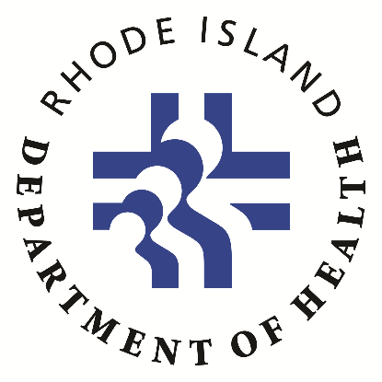
COVID-19 Vaccination Posting Requirement
Date Data Updated: July 15, 2021 | Data
Personnel/Healthcare Workers (Denominator):  - Includes employees, as well as volunteers, students, trainees and any individual whether paid or unpaid, directly employed by or under contract with the facility on a part-time basis or full-time basis.  - Reporting should include, but is not limited to: physicians, physician assistants, environmental, laundry, maintenance, dietary service, certified nursing assistants, therapists (e.g. respiratory, occupational, physical, speech and music therapists), social workers, clerical, other healthcare providers, administrative and support staff.  - Does not apply to a patient’s family member or friend who visits or otherwise assists in the care of that patient in a healthcare facility.  - If HCP were eligible to have worked in two or more facilities, each facility should include such personnel in their denominator.  - Include persons who work full-time and part-time; Count individuals rather than full-time equivalents. | Number of Personnel:  55
Cumulative number of HCP who have COMPLETED the COVID-19 vaccination series (Numerator):  - Dose 1 and dose 2 of Pfizer-BioNTech COVID-19 vaccine  OR  - Dose 1 and 2 of Moderna COVID-19 vaccine  OR  - One dose of Janssen (Johnson & Johnson) COVID-19 vaccine  (Data sources may include health records such as paper and/or electronic documentation of vaccination. Documentation of vaccination should include vaccine type and date(s) of administration). | Number of completed COVID-19 vaccinations:  30  Percentage of completed COVID-19 vaccinations:  54.5%
Cumulative number of HCP who have received PARTIAL COVID-19 vaccination series (Numerator):  - Only 1 dose of Pfizer-BioNTech COVID-19 vaccine  OR  - Only 1 dose of Moderna COVID-19 vaccine  (Data sources may include health records such as paper and/or electronic documentation of vaccination. Documentation of vaccination should include vaccine type and date(s) of administration). | Number received partial COVID-19 vaccination:  1  Percentage received partial COVID-19 vaccination:  1.8%

In compliance with Rhode Island Department Health Regulation 216-RICR-50-15-7:
https://rules.sos.ri.gov/regulations/part/216-50-15-7

